Weekly Arithmetic 10 a day w/b 22/6/20
75
55
Monday
- List all multiples of 10 up to 120.

- There are 18 books. George takes 1/3 of the books.
How many books does George take?

How many are left?

- Draw an arrow to show 70 on the number line

- What are the missing numbers in this sequence?

42, 37, ___ , 27 , ___ , 17, 12, ___ , ___

- Roses are sold in bunches of 5. Sophie wants to buy 33 roses. Can she? Explain your answer.

Tuesday
- Miss Whitney is thinking of a shape. She says a football is an example of this shape. What is the shape?

- 12 + 18 = _____
This is the same as
______ + 30
100 - _____
_____ x _____

- Complete this calculation:
_______ 3 = 7

- Izzah has just got home from school and is having a snack. What time could it be?

- Joseph says 485 is in the 5 times table. Is he right? How do you know?

- How many different ways can you make 54, using only addition? Write them in your book.

Wednesday
- List the name, number of faces, number of edges and number of vertices for this shape.
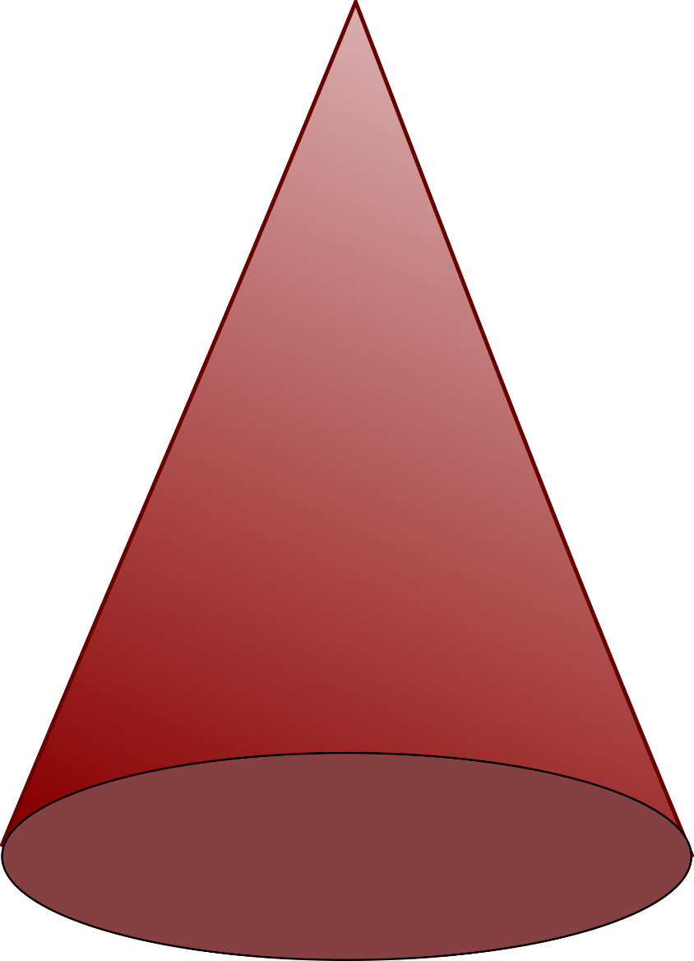

- A toy costs £1.50. How can you make this amount using the least amount of coins?

How many coins would you need if you were trying to use as many coins as possible?

- Abhiraj buys 20 sweets. He eats ¾ of the sweets. How many does he eat?

- Mahira gets up at 6 o’clock and it takes her an hour and a half to get ready. At what time is Mahira ready?

- Miss Handley says that 134 cakes can be shared equally between 2 people. Is she right? How do you know?
Thursday
- Irteza swims 17 metres. The pool is 25 metres long. How much further does Irteza need to swim to get to the end of the pool?

- Zed is looking at the clock. He says the minute hand is pointing to the 3 and the hour hand is pointing to the 6. What time is it?

- 5 children are standing in a line, but they have to be 2m apart from each other. How long is the line?
Top tip: Draw the line!

- Write the number 92 in words:

- If 10-1=9, what is 100-10?

How did you work it out?

- If A=1, B=2, C=3, D=4…all the way through the alphabet, what is G+P?
Friday

- Complete this fact family:

2 18 9

___ x ___ = ____
___ x___ = ____
___ ÷___ =____
___ ÷ ___ = ____

÷

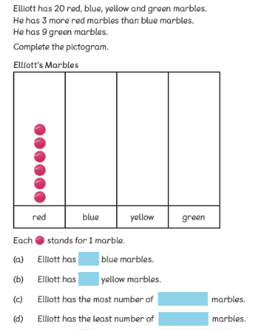
2. You might need counters, pencils, pebbles – basically anything you can count!- to help you with this one:

