Heymann Homeworking Menu – Nursery - Week Beginning: 20.07.20 (Sheet 15)
In the table, there are lots of different activities to choose from. You must complete the green boxes each week.
At least one 4-star activity should be completed each week. You can choose to do whatever you like each week. However, you must try to earn 20 stars by the end of the week. When you have completed an activity and a parent has checked it, you can colour the number of stars you have achieved. Happy star collecting!
Remember to check out our videos on Microsoft Teams/our webpage and let us know what you have been up to!
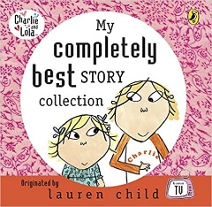  Share books including ones from the ‘Charlie and Lola’ series by Lauren Child. If you do not have any of these stories at home- you can YouTube ‘Charlie and Lola books’ and pick your favourites. |  |  |  |  |  |  | Get Dancing!  CBeebies iPlayer: Oti’s Boogie Beebies  Get dancing in your front room. Pick the episode you like the sound of most! We like the look of ‘Monsters’ and ‘Feeling Good’ |  |  |  |  | 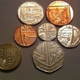  Discovering Coins – Have a look at some coins. What words can you use to describe them? Find out how much they are worth. Place some blutac on the back and put some paper over your coin. Rub over with a crayon to reveal the picture. Can you find out who the lady is on the back? |  |  |  |  |  | WELL DONE! We are so sad that it is the end of term and we can’t be together and celebrate your wonderful achievements. Please find a way to celebrate at home (maybe with cake or a mini party in your living room?) Also have a look at our class photo- can you spot yourself and your friends?
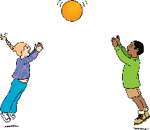  Play catch- Practise your throwing and catching skills. Start with a large ball/object and then see if you can use smaller ones. If you don’t have any balls at home you could use soft toys instead. Practice catching on your own and with someone else. |  |  |  |  |  |  | 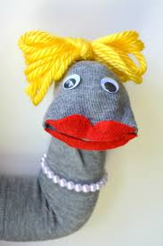  Make a sock puppet- find some old socks and make them into puppets by giving them faces and maybe some hair too!  Put on a show (you could make a stage out of a cardboard box) or poke your sock puppets round the side of a door! |  |  |  |  | Keep Calm – check out these activities from CBeebies. They are relaxation and mindfulness activities designed to help children to calm down if they feel stressed or anxious.  https://www.bbc.co.uk/cbeebies/joinin/seven-techniques-for-helping-kids-keep-calm |  |  |  |  |  | 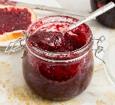  (WHOLE SCHOOL ACTIVITY) – National Preserving Week 2020 is a whole week of events designed to get people preserving their own food. Have a read about how preserving started and try following the simple recipe to make your own jam!
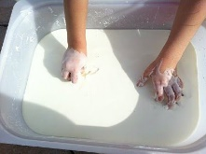  Cornflour and Water- Get a tray or large pan/bowl and mix some cornflour and water together (you could add some food colouring too)- Can you describe what it feels like? Get your hands messy- can you draw some shapes in the gooeyness/can you write your name?  (might be best to do outside) |  |  |  |  |  |  | 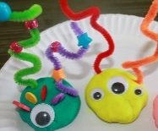  Monster Mash- Can you make or draw some funny monsters? (or use our picture cards PDF) Can you give them alliterative names. You could also decide their favourite alliterative things. E.g Googly Gary who likes to eat Grass  Bouncy Barry who loves Bubbles |  |  |  |  | 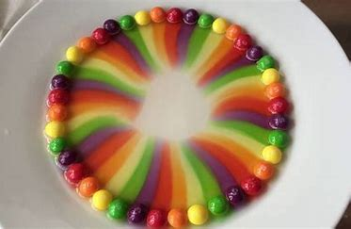  (VIDEO ON THIS PAGE) Rainbow skittles experiment- See what happens when you add hot water to skittles…  Challenge: can you make a repeating pattern with the skittles first? |  |  |  |  |  | Monster Milkshake Capacity - Can you understand and use the correct vocabulary to help the monsters find their milkshakes? (see PowerPoint/PDF)  You could make your own milkshake afterwards too 😊
Bonus
Stars:

