Heymann Primary and Nursery School

Nursery Handbook

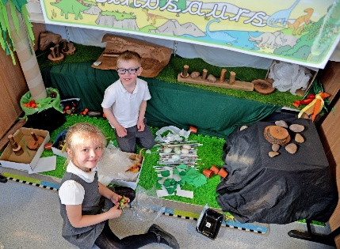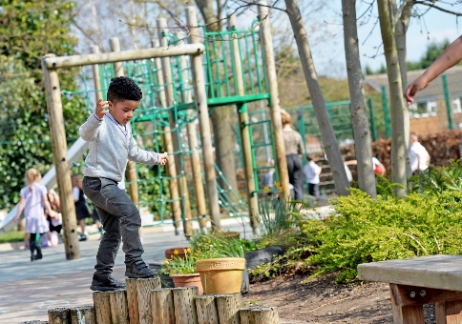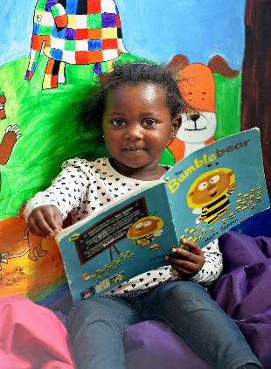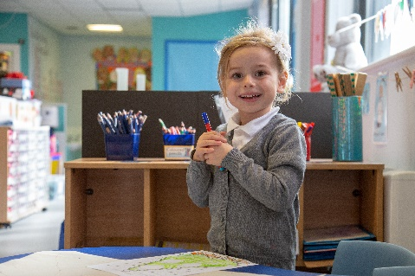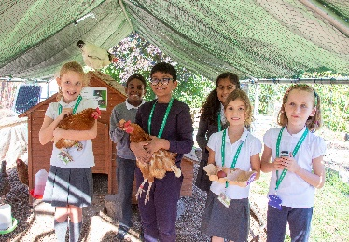



INTAKE: SEPTEMBER 2022



Rushcliffe Schools

Alliance

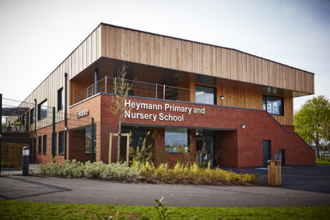

Contents

PAGE

Nursery at a glance 3

Welcome to our nursery 4

Getting ready for nursery 5

What to bring to nursery 6

The Early Years Foundation Stage Curriculum 7

The nursery day 8

Absence and Holidays 9

School Closures 9

Children’s Achievements 10

Moving to Reception 10

**Nursery at a glance**

Term begins: Thursday 1st September

Nursery session times: 8:30 – 11:30am and 12:15 – 3:15pm. Please bring your child to nursery and collect on time, particularly at lunchtime as we do not have long to reset for the afternoon session.

Where to come: Please bring your child to the nursery door, via the nursery gate, and collect from the nursery playground at the end of the session.

Breakfast club: This is available within Nursery Wraparound care and runs in the KS1 school hall Breakfast Club takes place in the KS1 school hall (entrance via the staff car park) after which the children are taken to nursery. Full details will be provided with your Breakfast Club booking.

Lunch club: The children have lunch in the KS1 school hall. If you are dropping off at 11:30am or collecting at 12:15pm please do so from the nursery door. Please note that lunch club costs £3.00 per day for your child to be supervised whilst eating their lunch and then playing. If you wish your child to have a hot lunch provided by school then an additional charge will be made via your child’s Schoolmoney account, this is our online payment facility for which you will be sent log in details at the start of term.

Day care: Please bring your child to, and collect from, the nursery door (or breakfast club/afterschool club if attending these clubs).

HOOSC (Heymann Out Of School Club): This is available within Nursery Wraparound care and runs in the KS1 school hall. Full details will be provided with your HOOSC booking.

Wrap Around Care: This is billed monthly, we regret there are no refunds for any absences for sickness, appointments, holidays etc.

Book bags: As most of our communications are online, and nursery children do not take reading books home, your child will not require a book bag for nursery.

Uniform: Children are welcome to wear school uniform if they wish. Please **name** all uniform, coats, water bottles and shoes.

Drinks: Please send water in your child’s water bottle, not juice. Free school milk will be ordered for your child if you register with Cool Milk.

Toilets: We expect the children to be out of nappies and be able to go to the toilet by themselves.

Curriculum Meeting: There will be a curriculum meeting in September/October where you can find out more about the nursery curriculum and have a chance to discuss how your child has settled into nursery.

Schoolmoney: This is our online payment facility for all payments to school including school dinners, trips, HOOSC, Breakfast Club and shop purchases. You will be given a username and log in password when your child starts in nursery.

**Welcome to our nursery**

We are delighted that you have chosen Heymann Primary School Nursery for your child and would like to welcome you to our school.

The Staff Team

The nursery teachers are Richard Hicking and Jude Lawrence. They are supported closely by a team of Teaching Assistants including Hollie Shaw who works in nursery full time. All staff will be working with all the children on a daily basis.

Richard Hicking

I will be teaching in the nursery at the beginning of the week, Monday to Wednesday. I have been working at Heymann as a class teacher for around ten years and I also have 3 children – Leo who is 7, Felix who is 4 and my new baby Gabriel. I love music, art and stories and I can’t wait to sing songs, draw pictures and learn through our play over the coming year.

Jude Lawrence  
I will be teaching in the nursery on Thursdays and Fridays. I joined Heymann in January 2022 and have a passion for teaching in the Early Years, where I have worked for many years! I have 4 children who are very close in age and are now all grown up, I feel very lucky to have 2 daughters and twin sons. I particularly love sharing stories, circle games and singing nursery rhymes and action songs and helping children to follow their interests to develop their learning and play.

Hollie Shaw

I’m Hollie, I will be working in the nursery full time. I have been working at Heymann as both a teaching assistant and in HOOSC (Heymann Out Of School Club) for a number of years. I enjoy working with the younger children and planning craft activities. I am very pleased to be working in the nursery and look forward to meeting your children.

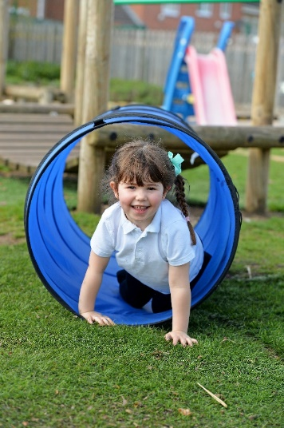

**Getting ready for nursery**

At nursery we understand that your child is very precious to you and they are still very young. However, if they can develop some independent skills before starting, this will make their nursery life much easier and more enjoyable. There are lots of things you can do at home to get your child ready to start in our nursery.

C:\Users\teacher\AppData\Local\Microsoft\Windows\Temporary Internet Files\Content.IE5\O9W3NCJG\MC900113404[1].wmfPersonal and Social skills

* Encourage them to become more independent by putting on their own coat and shoes, even if this takes a little time.
* Ask them to help you with some jobs around the house like clearing away their toys.
* Encourage them to take responsibility for their own things.
* Encourage them to go to the toilet by themselves and to wash and dry their hands.
* Teach them to blow their own nose with a tissue and to put the tissue straight into the bin.

Toilets

We expect the children to be able to go to the toilet by themselves when they start nursery. This includes wiping their own bottoms and remembering to wash their hands with soap when they have finished.

If your child does have an accident or needs some help in the toilets we will help and can provide clean spare clothes. Please wash any borrowed clothes and return them to school as soon as you can.

Please speak to one of the nursery staff if your child does have any toileting issues or needs to be reminded to go. If your child is struggling with toilet training please speak to one of us or your Health Visitor for advice.

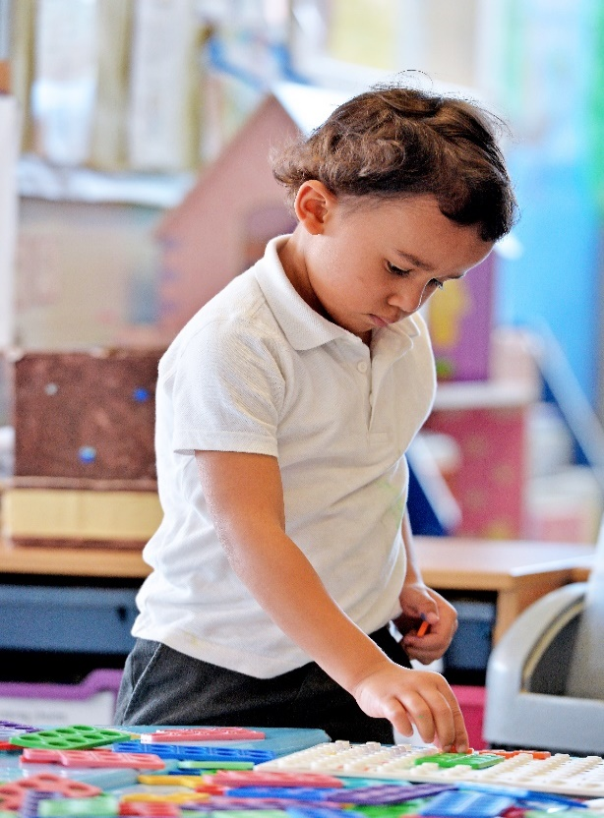

Learning skills

* Talk to your child and encourage them to take turns in conversations and to listen.
* Encourage them to recognise their own name written with a capital letter for the first letter only and then lowercase letters for the others.
* Share books with your child and encourage them to join in or retell the story in their own words.
* Count toys or objects and look for numbers in the environment.
* Sing songs and counting or nursery rhymes.

**What to bring to nursery**

* Spare set of clothes.
* Water bottle, filled with **water**, and **named**. It is really important that all children bring a water bottle every day**.** Children are encouraged to drink water regularly throughout the day to keep them hydrated.
* Coat, waterproof and **named.**
* Hat, gloves etc in winter, **named.**
* Sunhat in the summer, **named**. (Please apply long lasting sun cream onto your child before the nursery session).

School Uniform

At nursery your child does not have to wear school uniform. If you would prefer you child to wear uniform it can be bought and ordered from [www.just-schoolwear.co.uk](http://www.just-schoolwear.co.uk) or from their shop on Compton Acres.

Please ensure clothes your child wears to nursery are suitable for messy, active play and are easy to wash. We do have aprons available for messy activities, but can’t promise they will keep them totally clean.

Milk and fruit

The children have milk and fruit during snack time. Milk is available for all children (under 5’s free). To register your child to receive milk visit [www.coolmilk.com](http://www.coolmilk.com) or complete a form available from the school office.

One piece of fruit is available to all children each day. This may be an apple, banana, pear, tomato, carrot, orange or strawberries.

Medicines

Children who use inhalers or need an epipen should give a clearly named spare one to their teacher to be kept in the classroom.

Only **essential medicines** that need to be taken **four** times a day and have been **prescribed by the doctor** may be brought to nursery.

Medicines should be taken to the school office in the originalcontainer and a form giving permission to administer the medication completed. You will need to give **clear details** regarding your child’s name, dosage, time etc.

**The Early Years Foundation Stage Curriculum**

The Foundation Stage Curriculum is for all children from birth to the end of their Reception year. The curriculum is play based and the children have opportunities to learn through focused activities with an adult and through their own exploration. We provide learning opportunities for all areas of development both indoors and outdoors.

There are seven areas of development as follows:

The Prime Areas

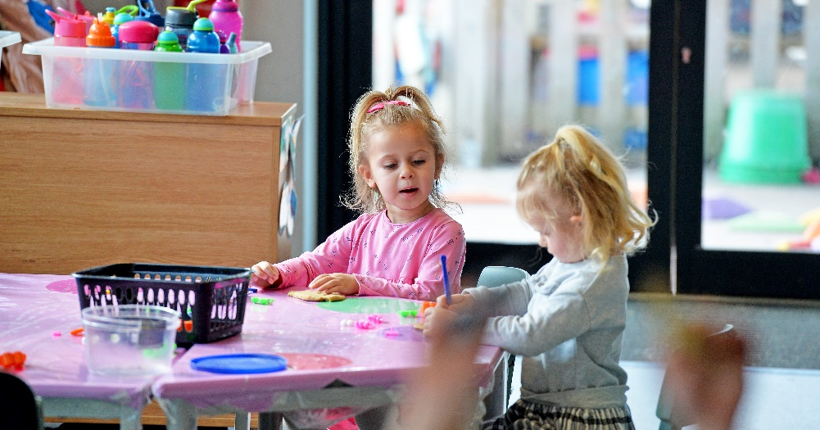

* Personal, Social and Emotional Development – Self Regulation, Managing Self, Building Relationships
* Communication and Language – Listening, Attention and Understanding, Speaking
* Physical Development – Gross Motor skills, Fine Motor skills

The Specific Areas

* Literacy – Comprehension, Word Reading, Writing
* Mathematics – Number, Numerical Patterns
* Understanding the World – Past and Present, People and Communities, The Natural World
* Expressive Arts and Design – Creating with Materials, Being Imaginative and Expressive

We plan topic-based activities and will update the nursery page on the school website to explain about our current topic. Weekly talk tasks help explain our weekly planning and what you can do at home to support your child. These can also be found on the nursery webpage. From time to time we plan some joint activities with Reception. You will be informed by email or notices on the weekly school bulletin email.

After your child has been at nursery for a few weeks you will be invited into school for a curriculum meeting. At this meeting you will be able to find out more about the curriculum and will be given information about supporting your child’s learning at home.

**The Nursery Day**

Morning nursery starts at 8:30am and finishes at 11:30am. Children attending our Lunch Club will be collected by the lunchtime staff from the nursery classroom.

Afternoon nursery starts at 12:15pm and finishes at 3:15pm. You can pick up from 3:00pm if that helps you collect other children.

Please try to get your child to nursery promptly, it is very unsettling for them to arrive when the nursery session has already started. However, we would prefer you to be late rather than have the day off!

The following is an example of a typical nursery day:

|  |  |  |
| --- | --- | --- |
| Morning session | Afternoon session | Activity |
| 8:30 | 12:15 | Registration and settling in |
| 8:40 | 12:25 | Group time |
| 8:55 | 12:40 | Free play in the nursery classroom and adult led activities |
| 9:20 | 1:05 | Outdoor play opens |
| 10:00 | 1:45 | Snack and group time |
| 10:15 | 2:00 | Free play indoor and out and adult led activities |
| 11:00 | 2:45 | Tidy up |
| 11:10 | 2:55 | Group time and session review |
| 11:30 | 3:15 | Home time |

Please ensure you collect your child promptly and make sure you let us know who will be collecting them each day. Children attending HOOSC (Heymann Out Of School Club) will be collected from the nursery classroom by the HOOSC staff.

If there are last minute changes or unexpected delays please telephone the school office.

Stay and Play Sessions

We hold regular stay and play sessions where you can come into nursery and play with your child during the session. Please see the weekly school Bulletin for more details.

**Absence and Holidays**

Please contact the school office first thing on the morning of your child’s first day of absence and each subsequent day of absence.

If your child’s attendance and/or punctuality is poor or erratic we will ask you to come into nursery and discuss this with us. If there is no improvement after an agreed period your child may lose their place at nursery.

If you are going on holiday during term time a holiday request form must be completed. These are available from the school office and on the Heymann website. Please be aware that absences may not be authorised for older siblings attending our school, in line with Government regulations.

**School Closures**

When your child starts nursery you will be given a list of school dates for the year. This will include school holidays and Inset days (days when the school and nursery are closed for teachers’ training).

On very rare occasions the school may be unexpectedly closed due to very severe weather or internal problems (eg. Flooding, no electricity)

If **very severe** weather occurs overnight please do **not** telephone the school but listen to Radio Nottingham or Capital FM. All school closures are broadcast at regular intervals when we have unexpected severe conditions.



**Children’s Achievements**

At nursery we celebrate all children’s achievements.

If your child receives a certificate or medal outside nursery they can bring it in to share with the other children.

We keep learning journals for the children to record the work they do at nursery. The children have some ownership over their journals and can choose special work to save in it.

During the Autumn and Summer terms we have open evenings and in the Spring we have a parent’s evening where you can come into the nursery and talk to the staff about your child. In the summer term we will send home a written report of your child’s progress at nursery.

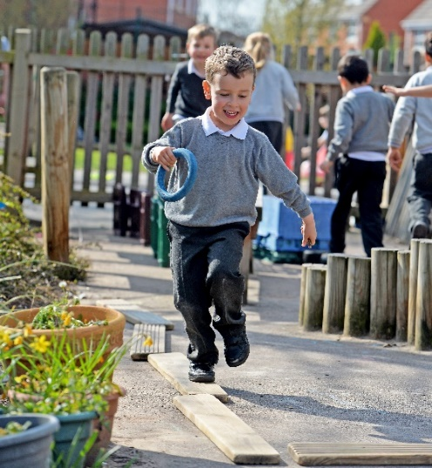

**Moving to Reception**

When your child is in their final term at our nursery we will begin to prepare them for moving to their reception class.

**Please remember that you must apply for a school place through your local Council. Attending our nursery does not automatically guarantee your child a place in our school.**

For children who have been successful in their application for Heymann Primary School, we will make close links with the Reception classes in order to help them with this transition. In the summer term the children will have opportunities to work with the reception children on a joint topic. They will also be able to spend time in the Reception Unit and meet their new teachers.

Children who are not moving into Reception at Heymann will be able to liaise with their new schools for this transition to take place. A copy of your child’s report and their nursery records will be sent to their new school.