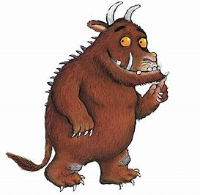
Gruffalo crumble

INGREDIENTS
- 115 g Self-raising flour
- 115 g Butter
- 150 g Granulated sugar
- 3 medium cooking Bramley apples or 2 apples and a handful of blueberries/blackberries

INSTRUCTIONS
- Preheat the oven to 190C/170C fan/350F

Mix together the butter, flour and sugar until you have a fine breadcrumb.
- Measure the ingredients into a bowl. If you are making the breadcrumbs by hand, rub the mixture between your fingers until you have a fine breadcrumb. Alteratively you can use a use a food processor to blast it all together into a crumb.
- Prepare the apples and place them in a baking dish.
- Peel, core and chop the apples and add them to your baking dish. Sprinkle over some raisins, blueberries, blackberries or cinnamon if you would like.
- Pour over the crumble mix
- Bake for 35-40 minutes
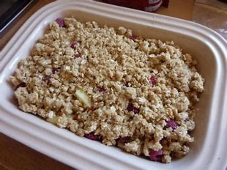
- It’s ready when the top looks golden and the apples have softened (check with a skewer or sharp knife if you’re not sure).
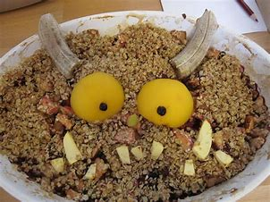

You could even give your crumble some Gruffalo features like these!

