We would love to hear about your child’s adventures over the Half Term holiday. Please use the spaces on this sheet to inform us about what you have been doing and any how clever your child is. They may have learnt a new skill ie zipping up their own coat or riding a bike; they may have taken part in a new activity ie swimming or gymnastics.

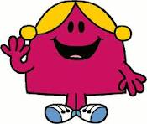
Tell Little Miss Chatterbox what you have been doing.

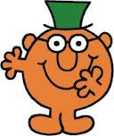
Tell Mr Clever how clever you have been.

