Heymann Homeworking Menu – Nursery - Week Beginning: 13.07.20 (Sheet 14)
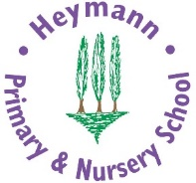 |  |  |  | In the table, there are lots of different activities to choose from. You must complete the green boxes each week.  At least one 4-star activity should be completed each week. You can choose to do whatever you like each week. However, you must try to earn 20 stars by the end of the week. When you have completed an activity and a parent has checked it, you can colour the number of stars you have achieved. Happy star collecting!  Remember to check out our videos on Microsoft Teams / our webpage and let us know what you have been up to.
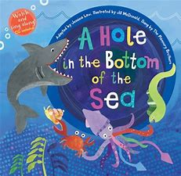  Share books – Including, There’s a hole in the bottom of the sea. Find this musical, rhyming story on You Tube here:  https://www.youtube.com/watch?v=R1Qn2bcZRTo |  |  |  |  |  |  | Sea creatures – check out this film about ‘animals that live in the sea’. I wonder which creature is your favourite?  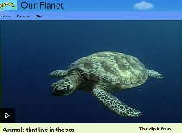  https://www.bbc.co.uk/programmes/p011l4gy |  |  |  |  |  |  | 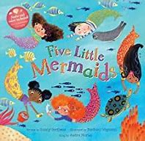  5 little mermaids – barefoot books on you tube. Can you practise counting backwards from 5 to 1? You could use 5 toys to help you and take one away each time.  https://www.bing.com/videos/search?q=5+little+mermaids+barefoot+books&docid=608009666406844172&mid=51B15B3F936C1015AF8951B15B3F936C1015AF89&view=detail&FORM=VIRE |  |  |  |  |  |  | 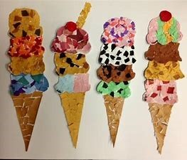  Create a collaged ice-cream – Can you use paper to collage an ice-cream. What is your favourite flavour? You could even add sprinkles!  This Photo by Unknown Author is licensed under CC BY-NC-ND
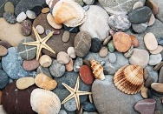  Make a collection of shells or stones - you could go on a pebble hunt if you don’t already have any. Use your describing words to talk about your shells/stones. How do they feel? Are they smooth, bumpy, rough. How do they look? Are they shiny, colourful or dull? |  |  |  |  |  |  | 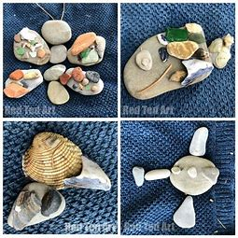  Natural Art – Once you have found some shells or stones you can use them to create a picture. Check out Mrs Stables video for some ideas. When you have finished take a picture and show us on TEAMs. If you are in school this week we will do this task with you. |  |  |  |  |  |  | Sharing a shell – listen to this story. The creatures in this story all argue. Can you remember how to be a good friend? Tell a grown up.  https://www.youtube.com/watch?v=JQ6LvmpoXjs  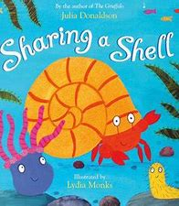 |  |  |  |  |  |  | 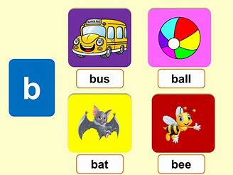  Beach phonics - Go on a ‘b’ for boat and beach hunt. How many things beginning with ‘b’ can you find?
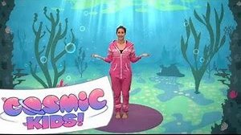  Cosmic kids yoga – Join in with the adventure of squish the fish.  https://www.youtube.com/watch?v=LhYtcadR9nw |  |  |  |  |  |  | 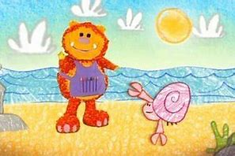  Get squiggling crab – Squigglet shows you how to draw a crab and a beach. Get your squiggle pads and squiggle sticks ready!  https://www.youtube.com/watch?v=cHvotNbKeA4 |  |  |  |  |  |  | Boats – Using recycled materials, can you make a boat that floats? Check out Miss Inglis’ video to help you. We would love to see your boats on TEAMs .  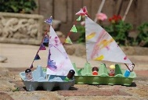 |  |  |  |  |  |  | Whole school task – Thinking about celebrations. The whole school task this week is about the French festival Bastille Day. Talk to a grown up about which celebrations are important to you and your family.
Bonus
Stars:

