**Weekly Arithmetic 10 a day**  w/b 30.3.20

**Monday**

1. I have 2 20p coins and 1 50p coin. How much money do I have? Jack has 80p and he says he has more money than me. Is he right? Explain why.
2. I am thinking of a shape. It has 5 vertices, 5 sides and 1 flat face. What is my shape?
3. Amelia is 80 cm tall. Samuel is 7 cm taller than Amelia. How tall is Samuel?
4. There are 35 flowers in a vase. I want to share the flowers between 7 children. How many flowers will each of them get?

5. There are 40 gel pens and I need to share them fairly between my 2 friends. How many gel pens does each friend get?

**Tuesday**

1. I am thinking of a shape. It has 6 vertices and 5 sides. What shape is it?
2. 11 + 9 = _____

This is the same as

13 + ______

24 - _____

_____ x _____

1. There are 5 houses on the road. Each house has 4 people living in it. How many people are there all together?
2. Jackie has 35p. Kevin has 6 5p coins, a 10p coin and a 20p coin. He says she has the same amount of money as Jackie. Is he right? Show your working out.
3. It is 8ºC today. Tomorrow it is going to be 5ºC warmer. What is the temperature going to be tomorrow?

**Wednesday**

Put the following numbers on the numberline: 19, 12, 27

1. There are 50 people on the bus. 16 get off at the first stop and 9 get off at the second stop. How many people are left on the bus?

Fill in the gaps for what you do at different times of the day on a normal school day.

1. At **7am** I…….

At **10:30am** I…..

At **12:00pm** I…..

At **3:10pm** I…

At **5:00pm** I….

At **7:00pm** I….

1. There are 9 tables in the in the dinner hall. 10 children sit at each table. How many children are in the dinner hall?
2. There are 30 sweets. Each child has 3 sweets each. How many children are there?

**Thursday**

1. Draw out the coins in as many different ways as you can to make 42p.
2. Bananas cost 15p each. Tim spent 45p. How many bananas did he buy?
3. 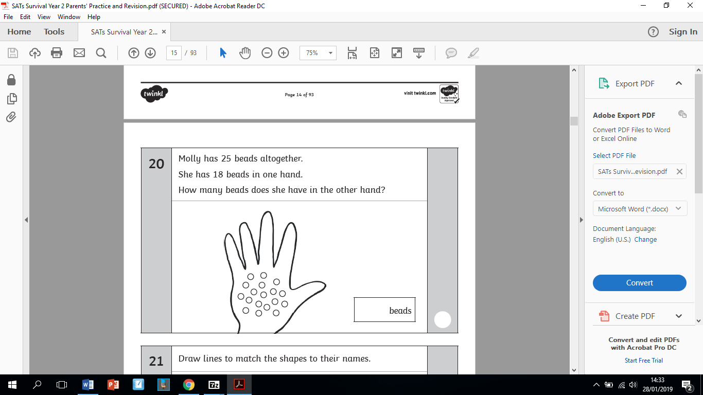
4. There are 30 cakes. 6 cakes were eaten. How many cakes are there left?

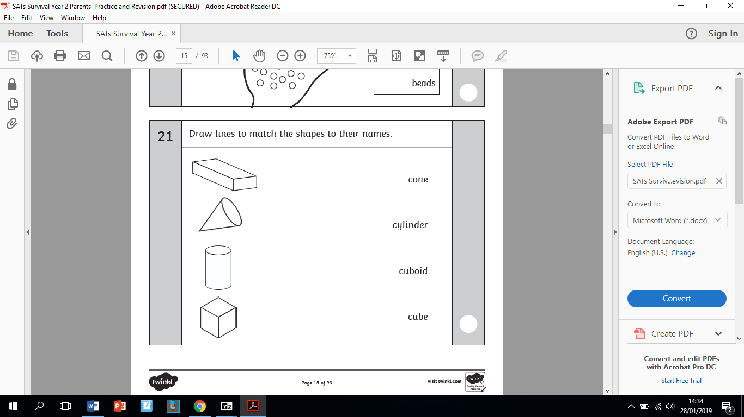

**Friday**

Put the following numbers on the numberline: 22, 35, 38

1. There are 50 people at the supermarket. 12 people buy bags of rice, then 7 more people buy bags of rice. How many bags of rice have been sold altogether?

Fill in the gaps for what you do at different times of the day at the weekend.

1. At **8 am** I…….

At **10:30am** I…..

At **12:00pm** I…..

At **3:00pm** I…

At **5:00pm** I….

At **7:30pm** I….

1. I have 15 chocolates and give 6 away to my neighbour. How many chocolates do I have left?
2. There are 50 oranges and 30 children in the class. Each child has 1 orange each during milk and fruit. How many oranges are left over?

40

30

20