A New Beginning in Year Three Lilac



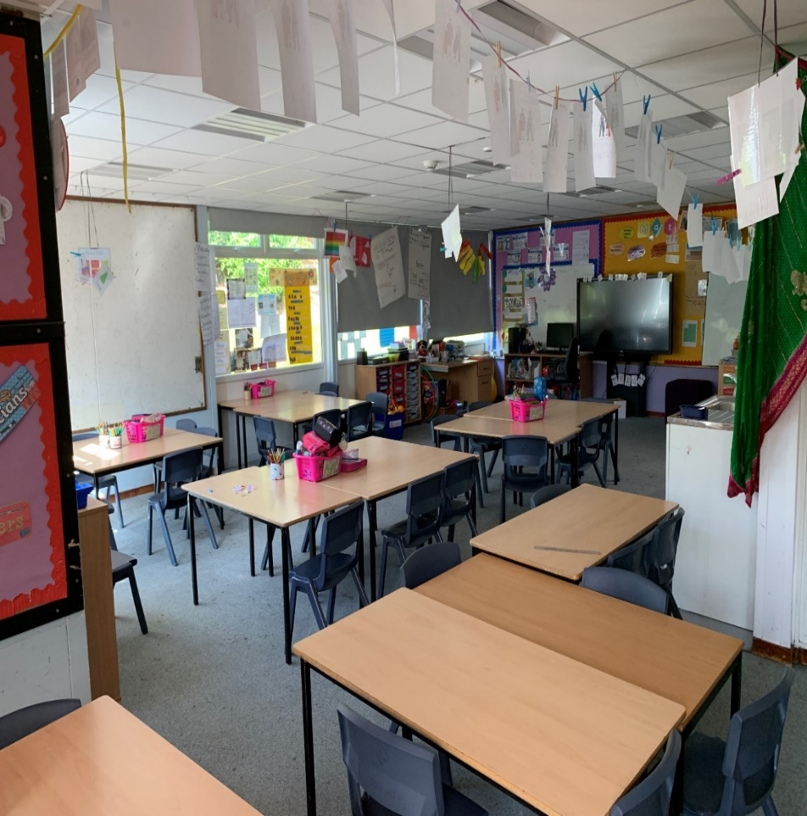

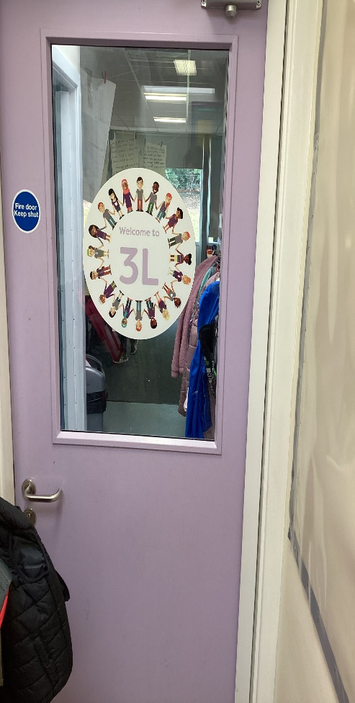

This is the classroom where I do my writing, drawing, number work painting and lots of exciting things.

mathspaint 1

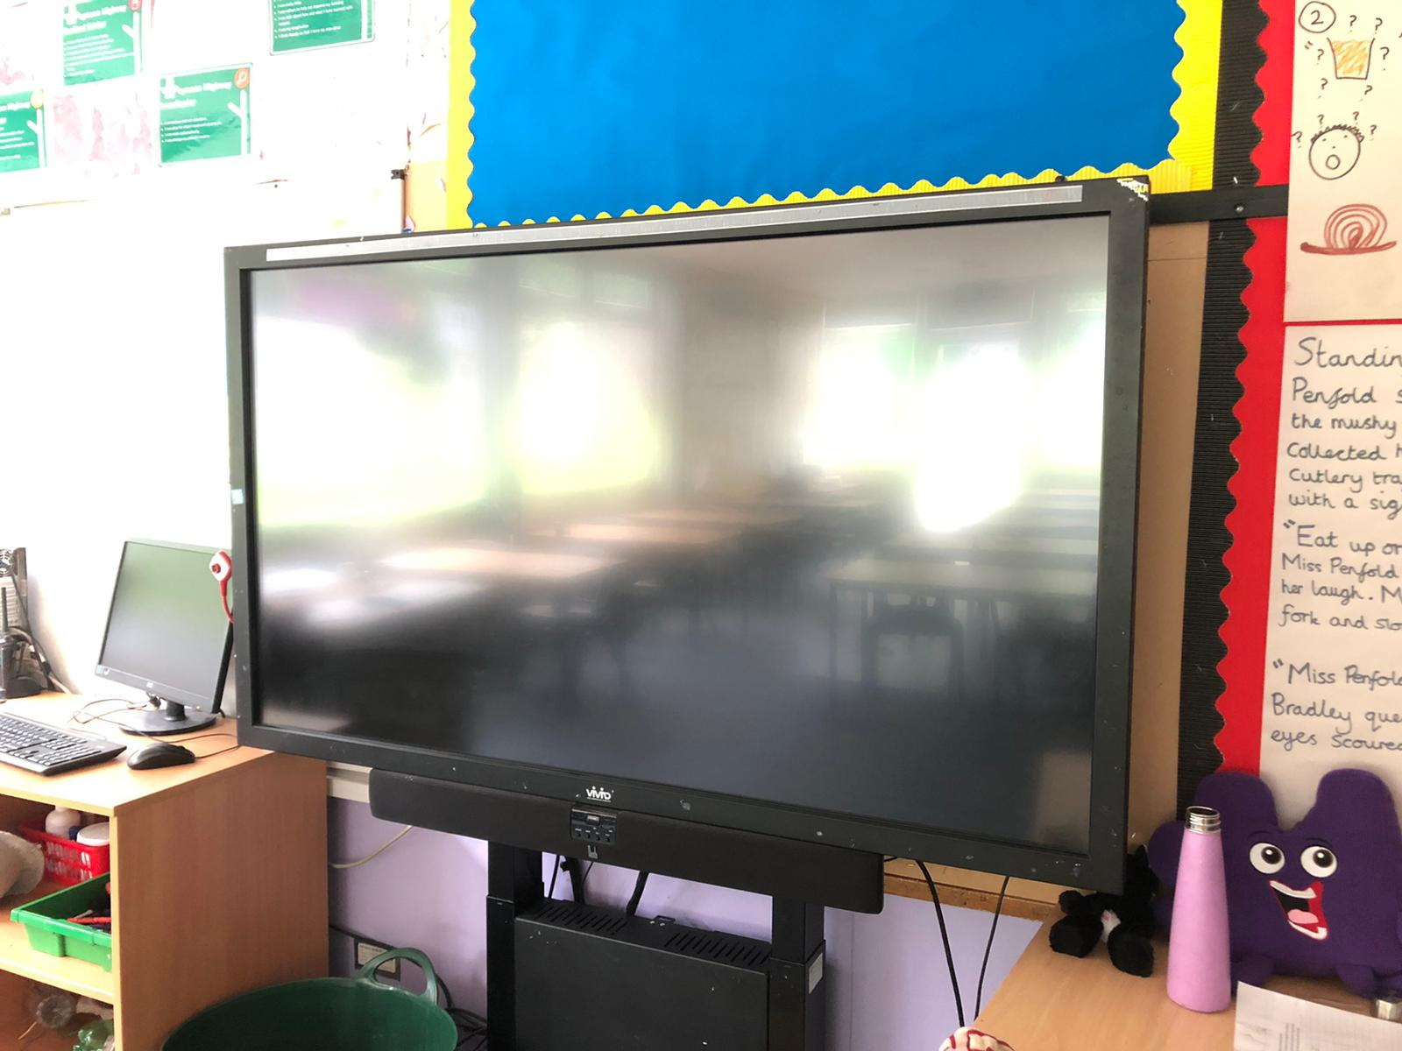

This is the interactive board that my teacher

will use to show us what we are going to do

timetableeach day.

Here is the book corner.

There are lots of exciting books to read and share with a friend.

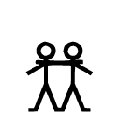

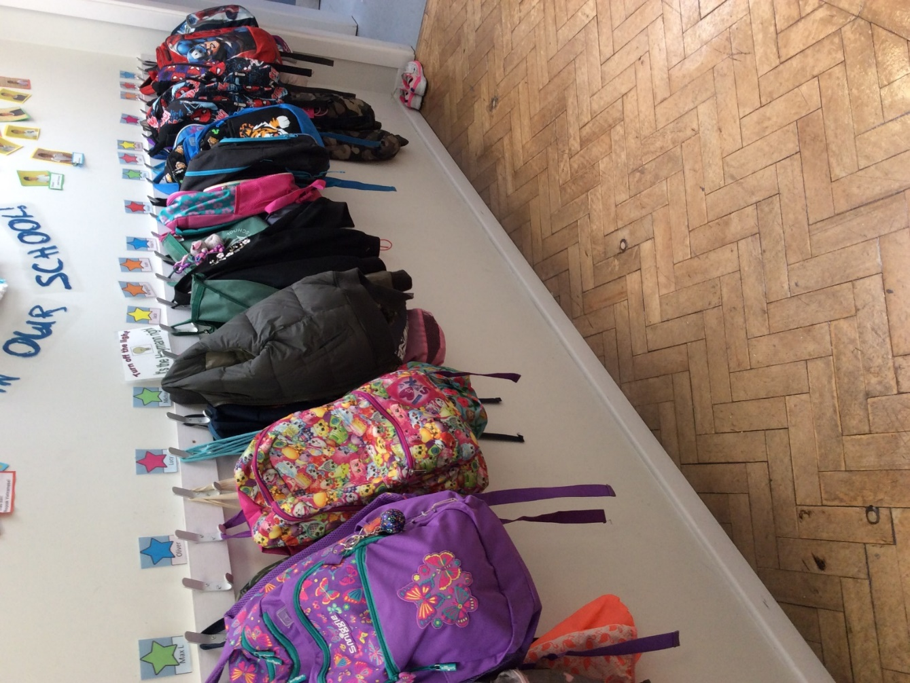

put coat onThis is where I hang my coat.

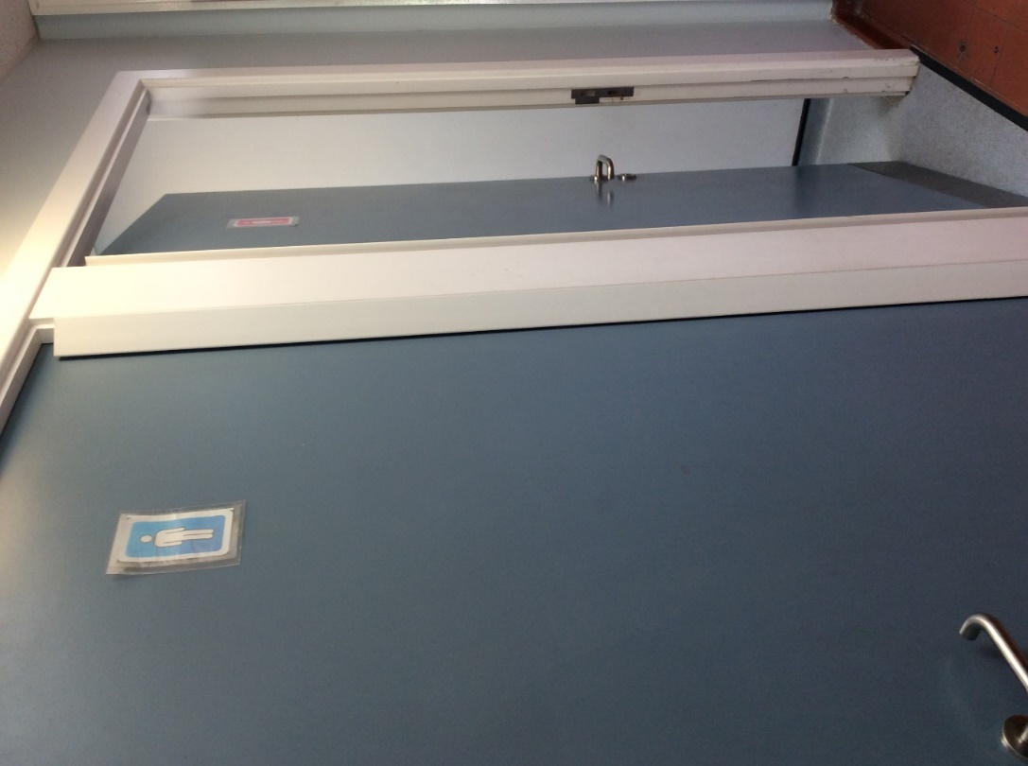

This is where I go to the toilet.

toilet_aI must remember to ask my teacher before I go.

ask

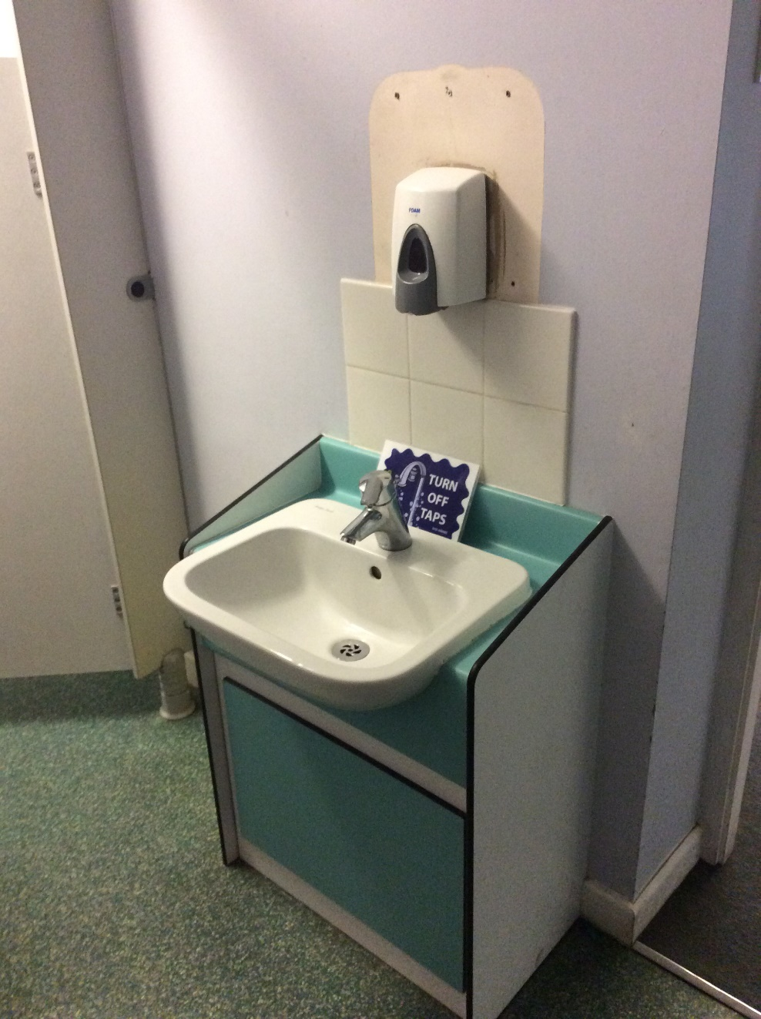

This is where I wash my hands.

I must remember to wash my hands when I have been to the toilet.

wash hands

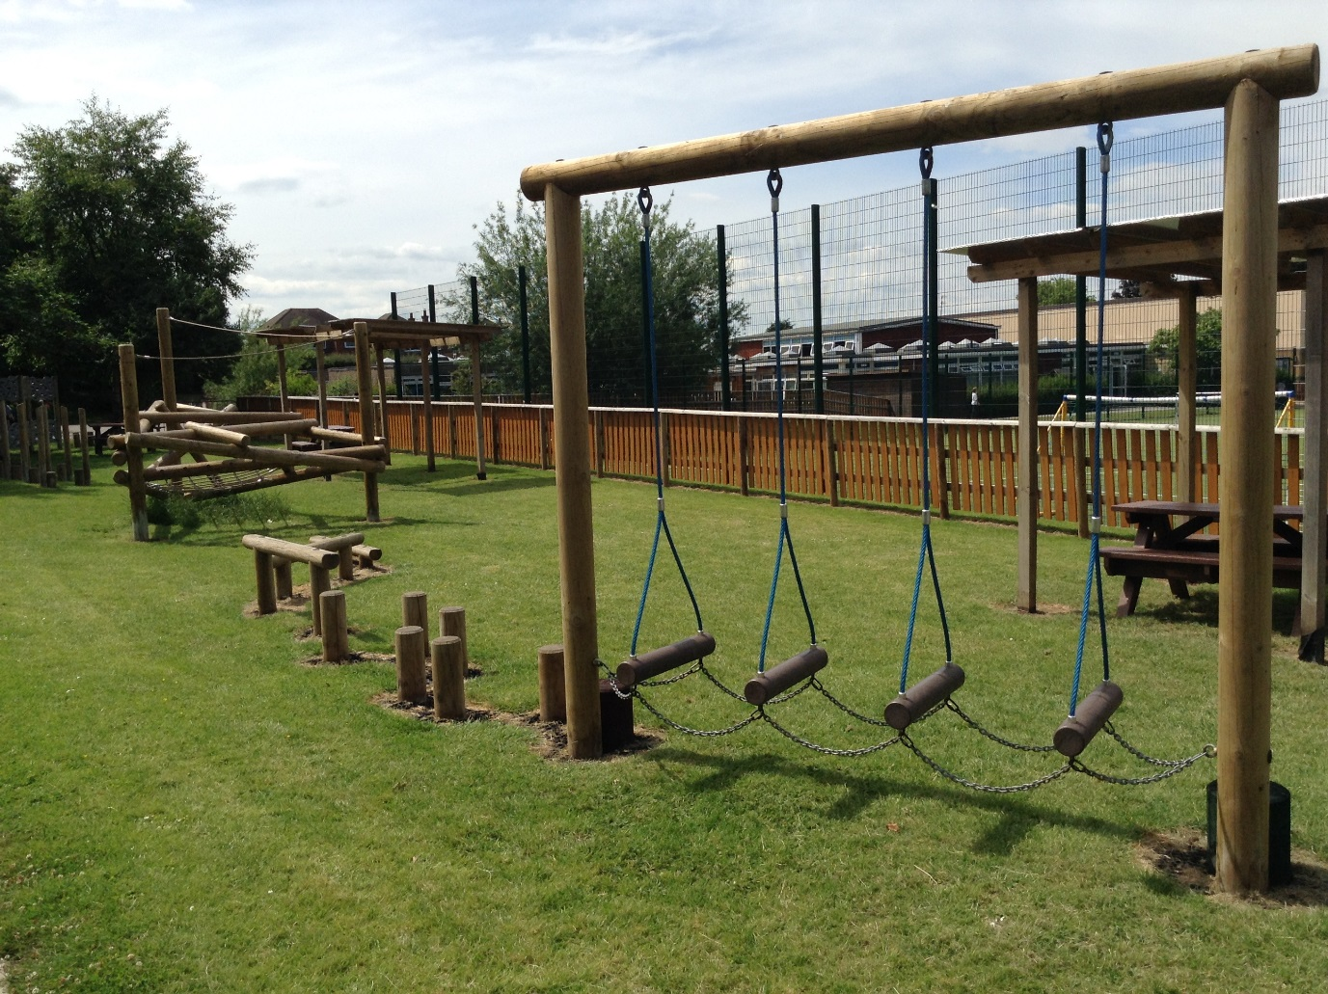

playThis is the trim trail where I can sometimes play. I need to have an adult with me.

Mr Arch

Miss Lowe

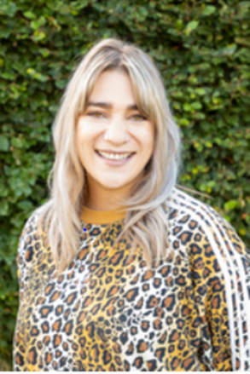These are adults around school who have great listening ears and are always around to listen to what is happening at school and at home.

teacher

Miss Goswami

This is the playground and the MUGA where I play at play time and at dinner time when I have eaten my dinner.

play

This is my teacher

Miss Raywood.

teacher

These are my teachers that teach me R.E, Spanish, Environment and Music.

Mrs Cameron

Spanish

Mrs Palmer

R.E.

Mrs Nicholls

Environment/Music

These are the T.A's working in year three.

