**A New Beginning in Year Three Turquoise**

Heymann Primary School

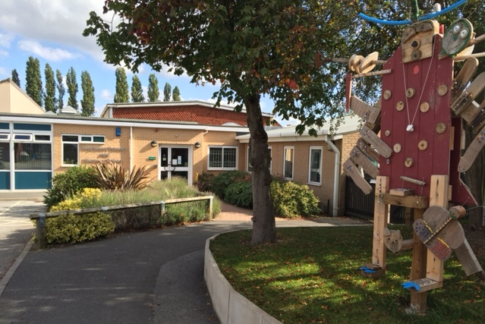

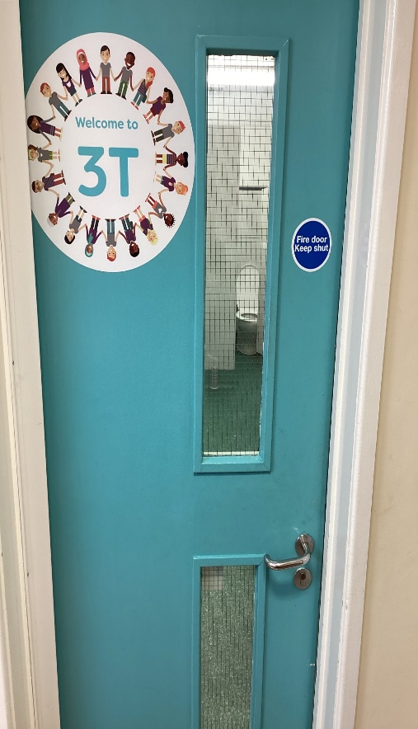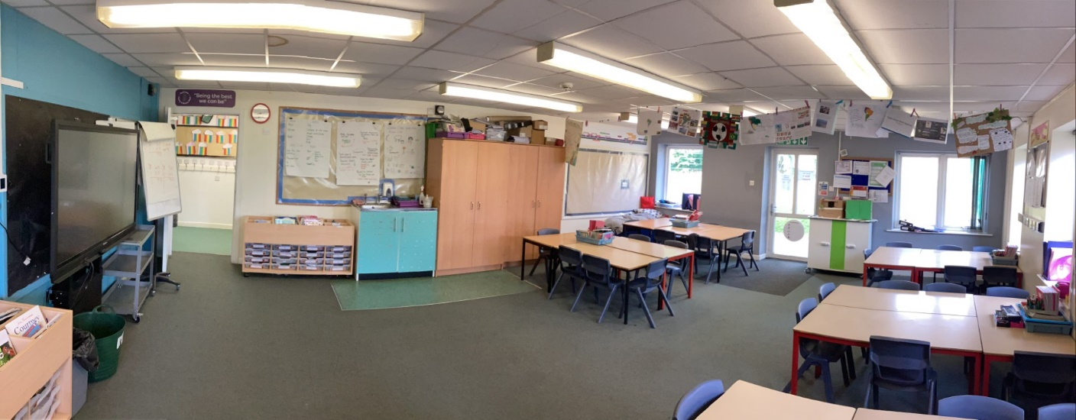

This is the classroom where I do my writing, drawing, number work painting and lots of exciting things.

mathspaint 1

This is the interactive board that my teacher will use to show us what we are going to do each day.

timetable

This is the Year 3 Ipad trolley. The Year 3 Ipad trolley is kept in 3T

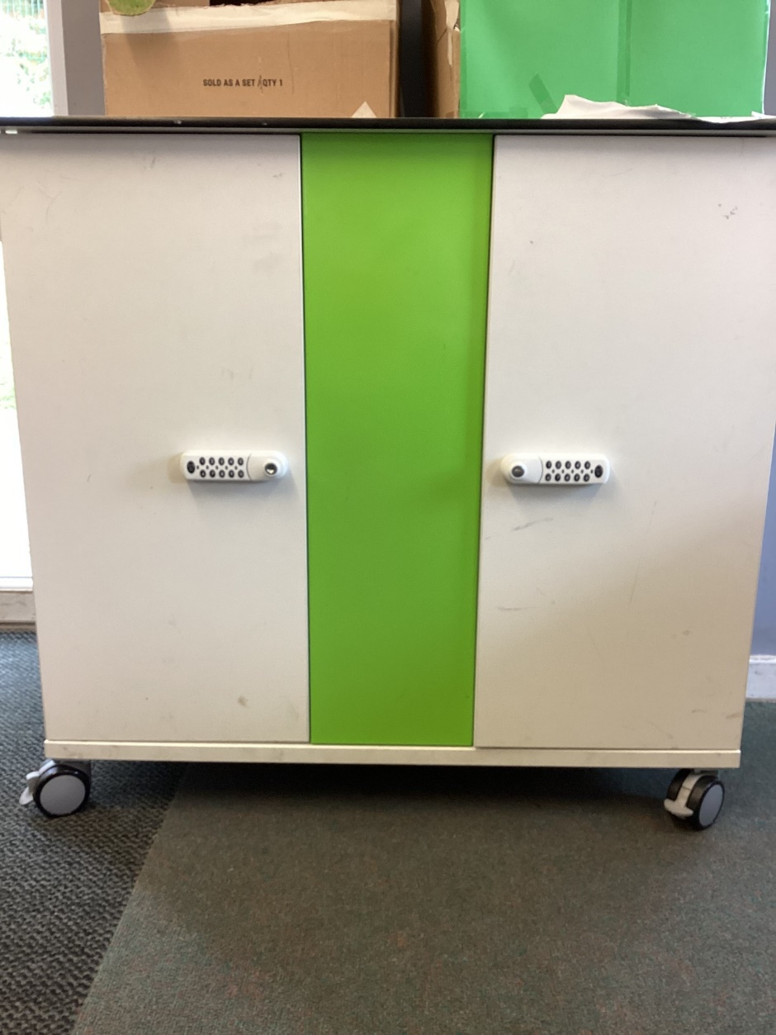

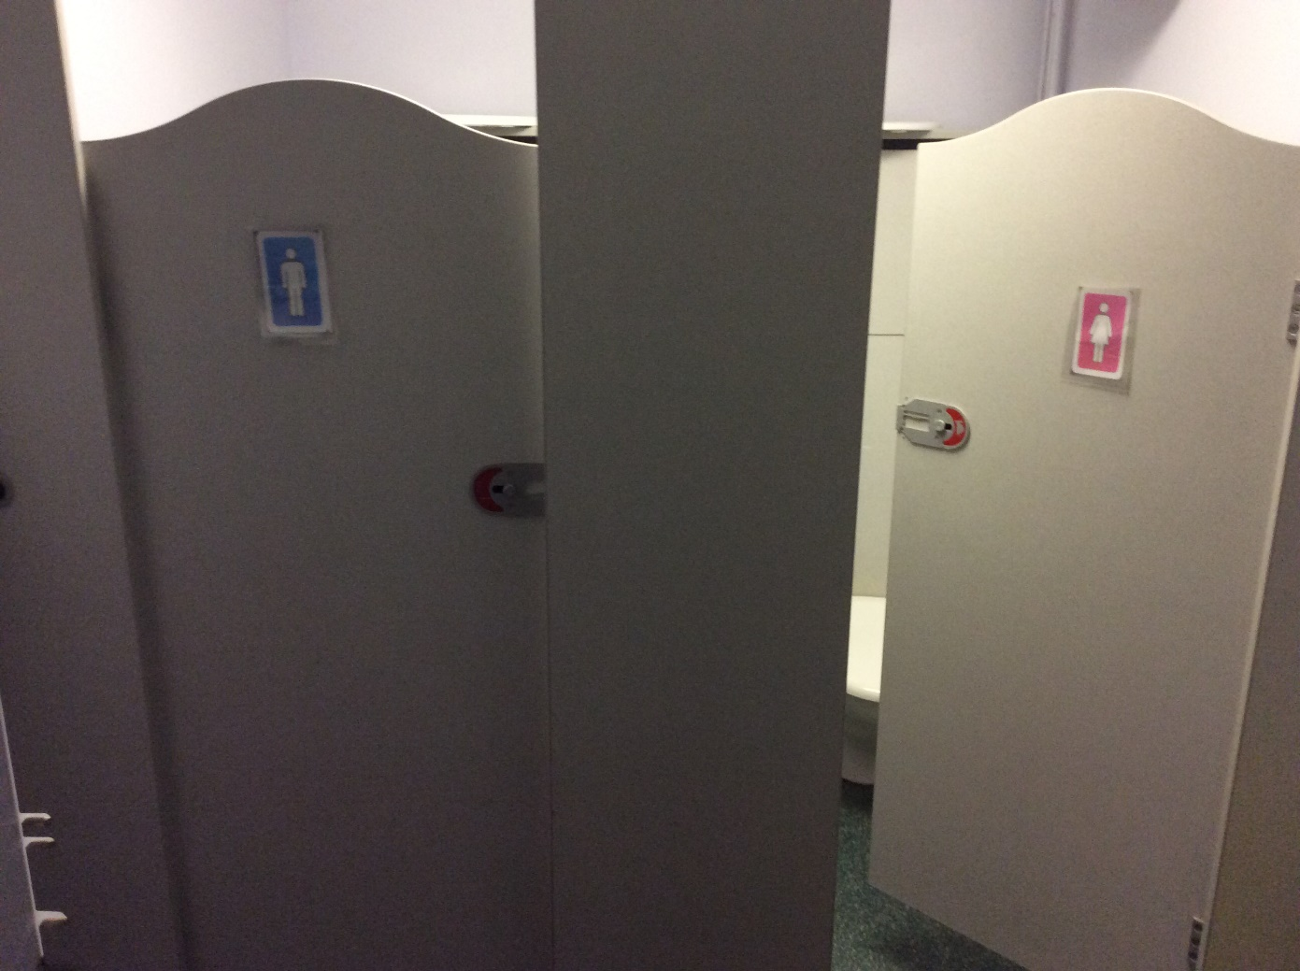

This is where I go to the toilet.

I must remember to ask my teacher before I go.

toilet_aask

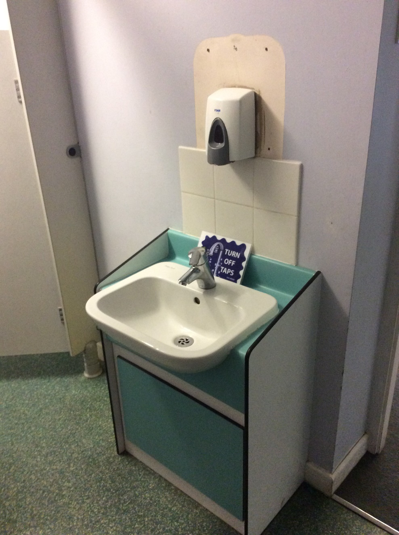

This is where I wash my hands.

I must remember to wash my hands when I have been to the toilet.

wash hands

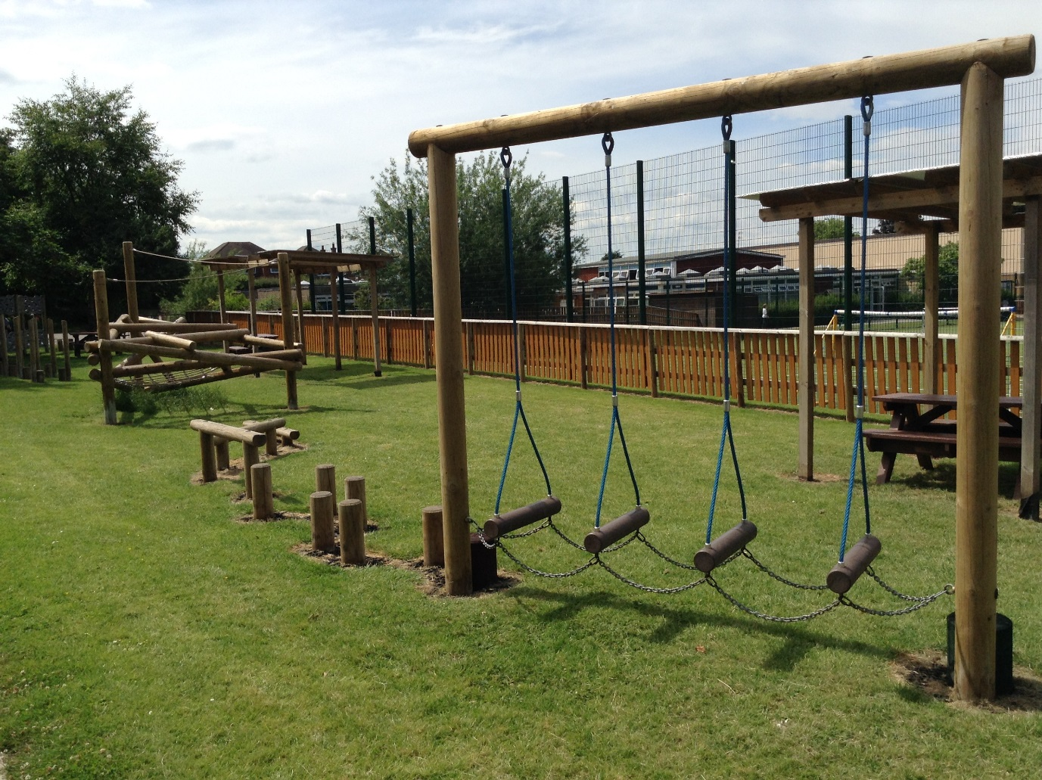

playThis is the trim trail where I can sometimes play. I must have an adult with me.

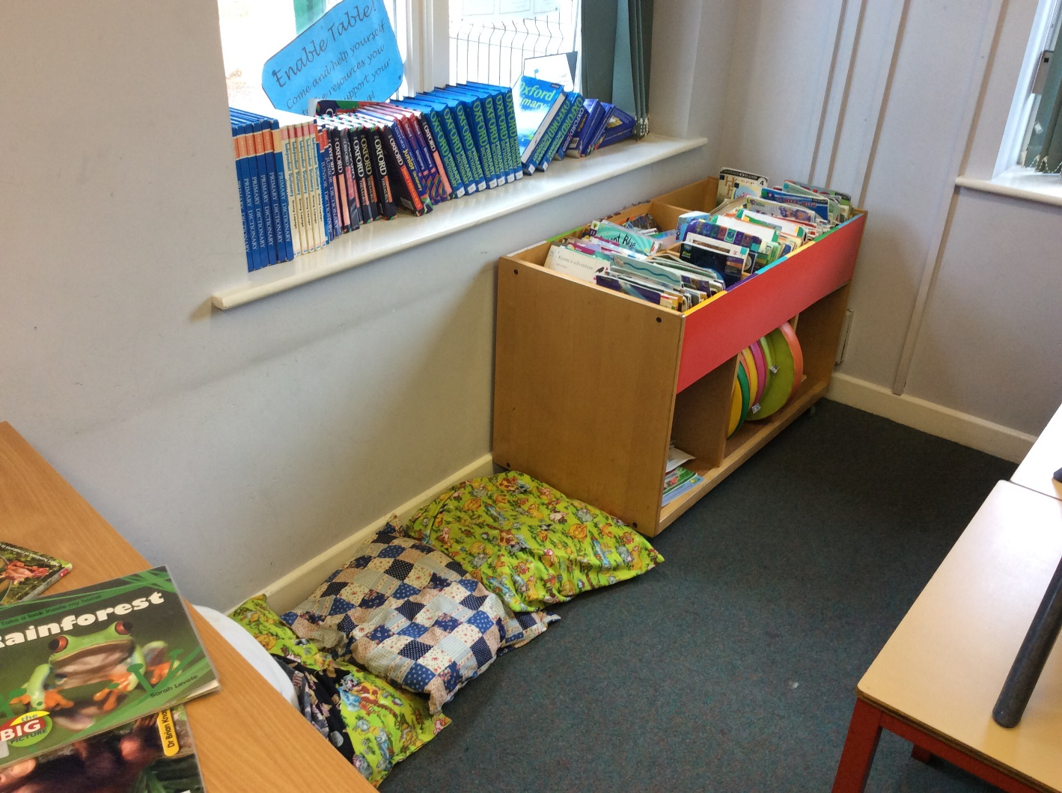

Here is the book corner.

There are lots of exciting books to read and share with a friend.

bookfriend

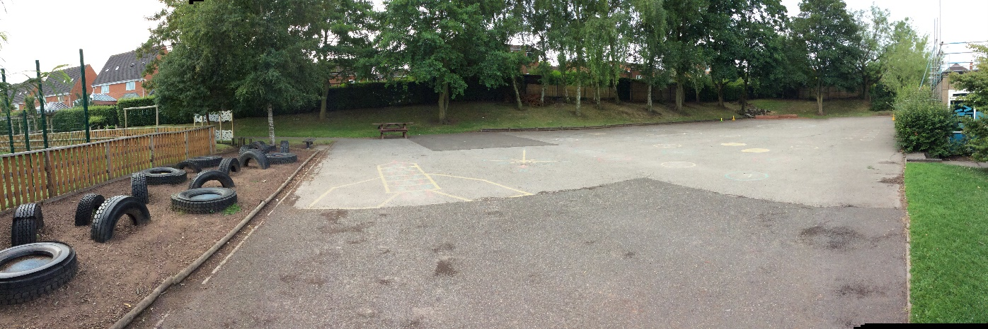

These are the playgrounds where I play at play time and at dinner time when I have eaten my dinner.

play

Mr Sills Mrs Marriott

teacherThese are my teachers

These are my teachers that teach me R.E, Environment and Spanish.

Mrs Cameron

Spanish

Mrs Palmer

R.E

Mrs Nicholls

Environment/Music

These are the T.A's working in year three.

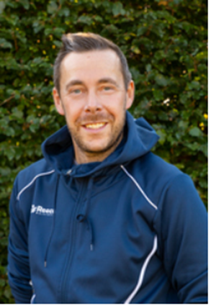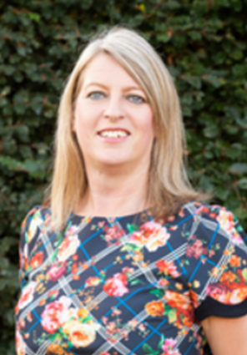

Miss Lowe

Mr Arch

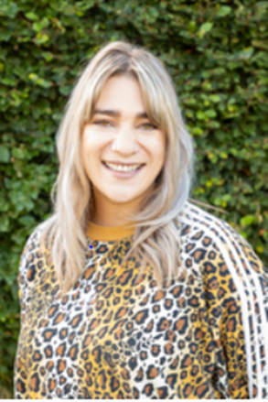

These are adults around school who have great listening ears and are always around to listen to what is happening at school and at home.

Miss Goswami