**Challenges this week**

Sort the items into two groups

Make a mother’s day card

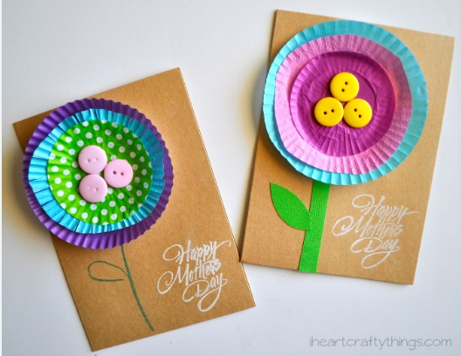

Circle art - look carefully at art by SH Raza

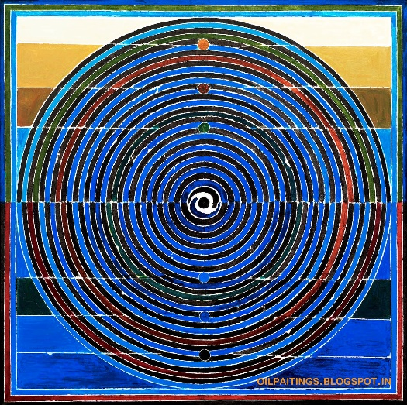

Go on a circle hunt outside

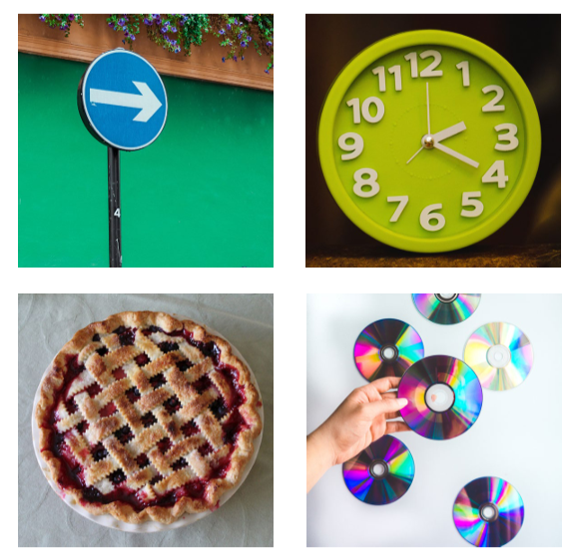

Make some binoculars or a telescope