**Challenges this week**

Use the numicon and sort the pieces

Draw your favourite toy and write your name

Go on the hunt outside

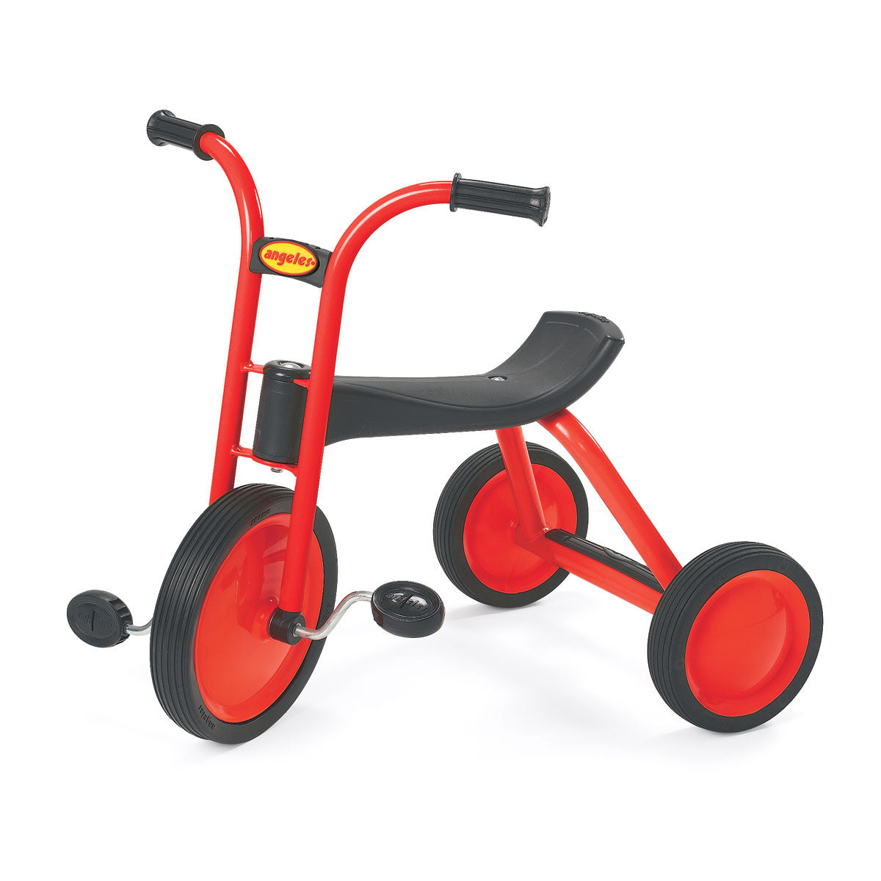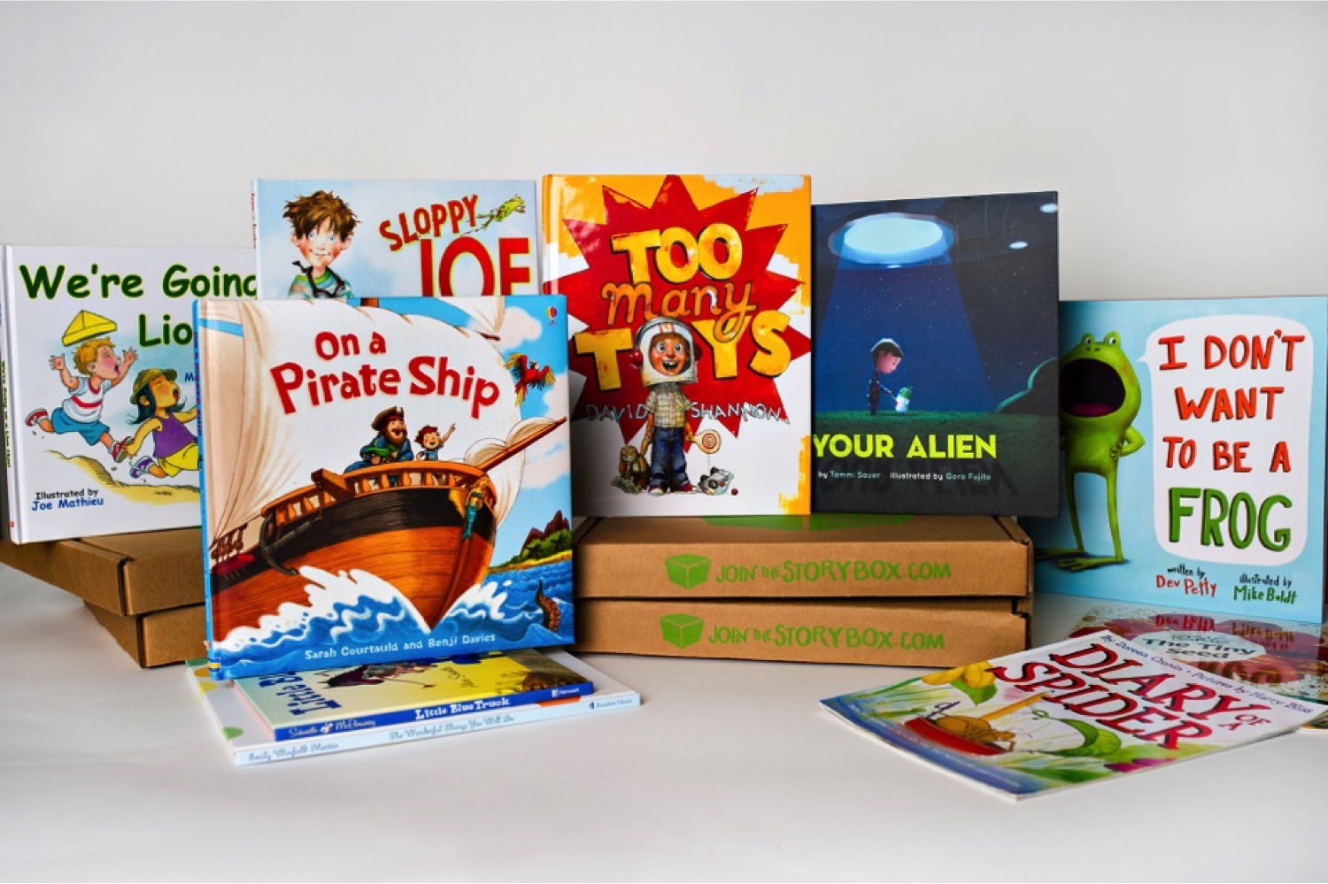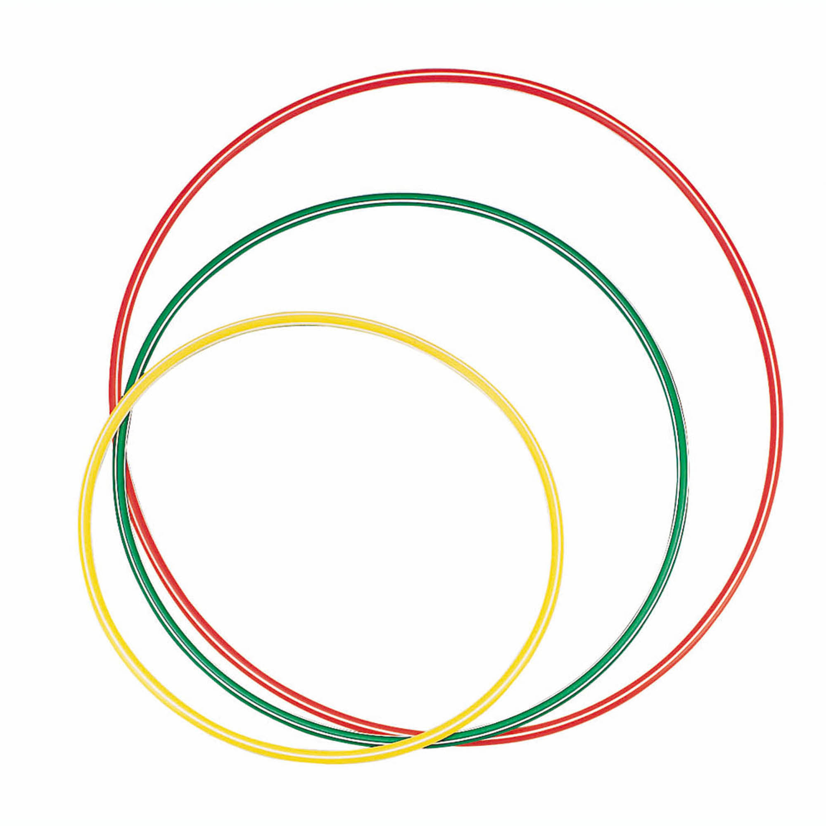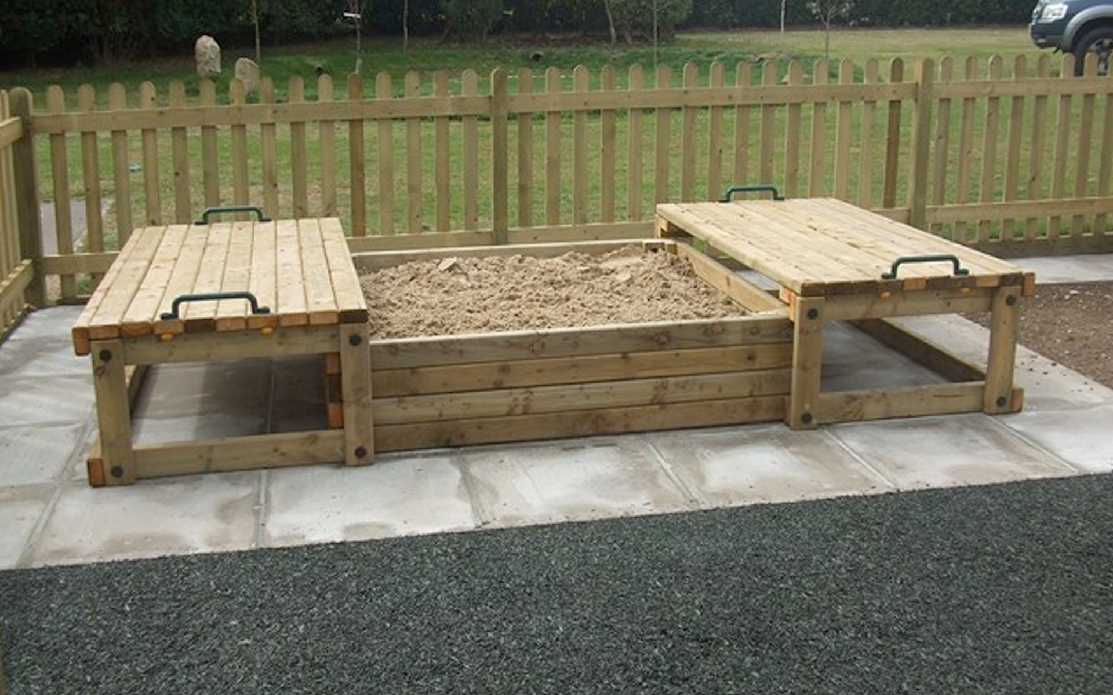

Build a model

