**Challenges this week**

Make a daffodil using paper

Find ways to make 7 using the ducks and pond

Colour and fold a bunch of flowers.

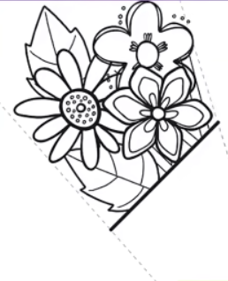

Build an obstacle course

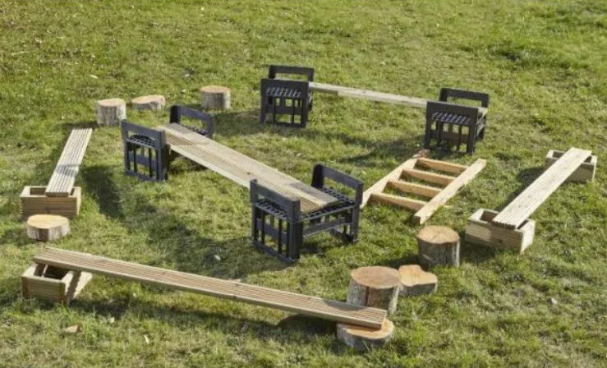

Draw a story map

