**Challenges this week**

Write your Jack sentence



Make a doubles ladybird



Draw a map of your storyland

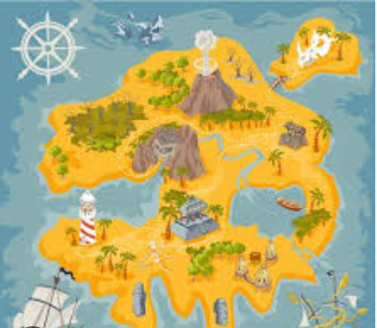

Make a story land

Create your own story map to tell the class

