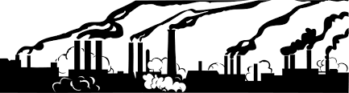

The Industrial Revolution – a change for the better? 1760 - 1840
Name | Picture | Significance
Thomas Newcomen | 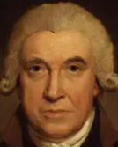 | Inventing the first steam engine
Lord Shaftesbury | 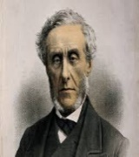 | A politician who improved conditions for children in mines and mills
Spinning Jenny | 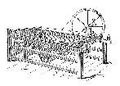 | Used in the textile industry to spin cotton  thread onto  a spool. Invented by James Hargreaves
Steam Pump | 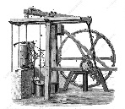 | Used to power machines for the manufacturing industry. Invented by James Watt
Power Loom | 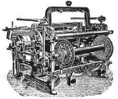 | Used to weave cloth and fabric in the textile industry. Invented by Edmund Cartwright
The Rocket | 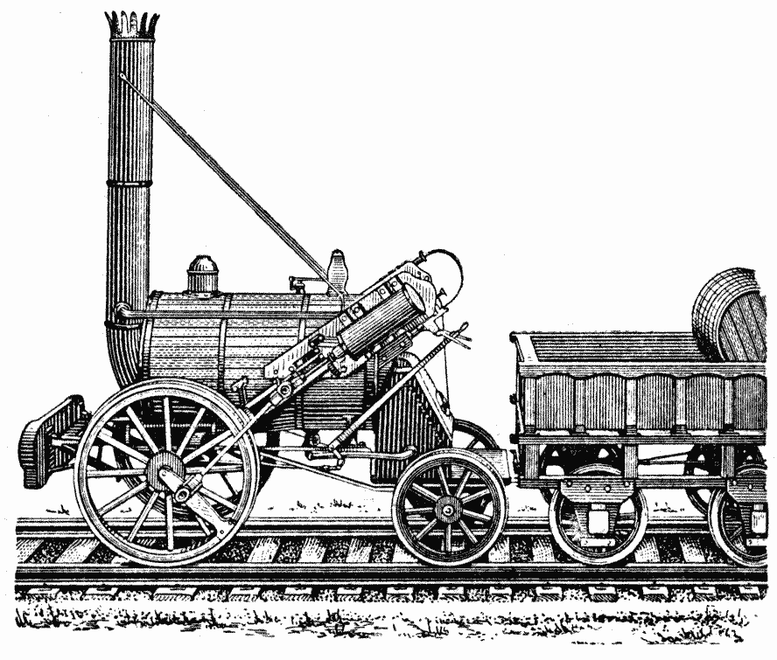 | Steam locomotive to move products and people on the railway in the transport industry. Invented by George Stephenson
1712 | 1764 | 1765 | 1785 | 1796 | 1829 | 1833 | 1842 | 1844 | 1848
Thomas Newcomen invents the first steam engine. | James Hargreaves invents the Spinning Jenny making it faster to spool cotton | James Watt improves the steam engine making it more efficient. | Edmund Cartwright invents the Power Loom increasing fabric production. | Edwin Jenner discovers the smallpox vaccine – recognising vaccines as a prevention of disease | George Stephenson invents the Rocket leading to the invention of the railway. | Lord Shaftesbury introduces The Factory Act. | Lord Shaftesbury introduces The Coal Mine Act. | Lord Shaftesbury starts The Ragged School Union. | Introduced the Public Health Act stating authorities e.g. remove waste, collect rubbish and provide clean water.

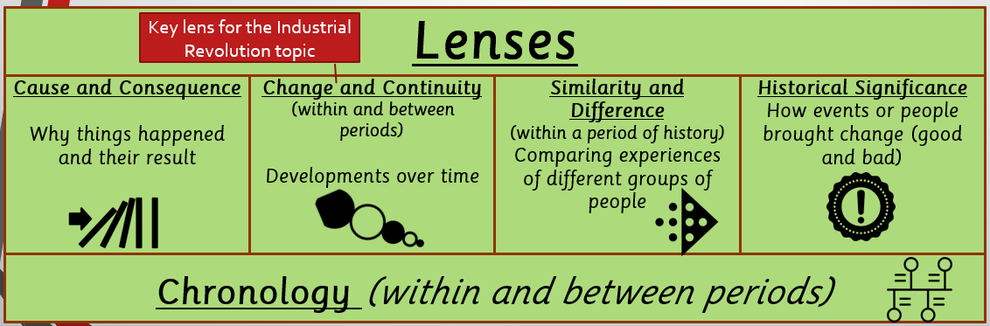
Substantive Concepts
  City |   Revolution |  |   Rights |   Rules/Law |   Society
Key Vocabulary
Industrial Revolution  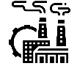 |  | A huge change in Britain in which it moved from rural and agriculture to factories and towns and cities due to steam power.  Industry – making of products in a factory.  Revolution – a sudden and huge change.
  Act |  | A written law passed by government.
Agriculture  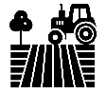 |  | Farming and the methods that are used to raise and look after crops and animals.
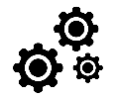  Mechanisation |  | Introduction of machines into a process that was done by hand
Manufacture  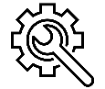 |  | To make something in a factory, usually in large quantities.
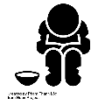  Poverty |  | The state of being extremely poor.
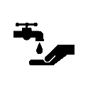  Sanitation |  | Keeping places clean and healthy, especially by providing a sewage system and a clean water supply.
  Urbanisation |  | A shift from rural living to towns and cities
- Farmers or weavers
- Limited steam power and coal use
- No factory working
- Women and children work on the land
- Machines invented to do farming/weaving
- Steam power to run whole factories
- Coalfields doubled in 30 years
- Unsafe working conditions, no holidays
Jobs and working
- Travel by road, foot or horse & carriage
- No air travel
- Limited water travel on canals
- Extensive railway network, including the Great Western Railway, Midlands Railway
- Development of airships
- Development of iron steamships
Transportation
- Had to pay to go to school
- Most children went out to work
- No right to education
- Teachers reserved for the rich
- Few people could read and write
- Ragged schools (free schools) opened
- Law for compulsory school for School all children aged 5 – 12.
- Most people learnt to read and write
- Use of canes and slate
Education
- Disease spread due to poor hygiene
- Cholera epidemics
- People didn’t know germs cause disease
- Most babies died at birth
- Vaccine for smallpox
- People learnt germs cause disease
- Doctors could put patients to sleep
- More babies and mothers survived
- Road structure – mostly coaches and wagons on Great North Road
- Agriculture based
- Some coal exports and mining
- Rural garden housing, spaced out
- Described as a beautiful town
- Canals and railway for transport
- Large textile industry for hosiery, lace and framework knitting
- Raleigh Bicycle and Boots founded
- Described as worst slum in British Empire - cheap, over-crowded houses, polluted sanitation, shared dirty tap water.
- 80% of the population lived in the country in cottage houses
- City housing – back to back terraces
- Open sewers, shared toilets
- No clean running water.
- Population – 50% lived in towns/cities
- People linked hygiene and disease
- Sanitation laws for clean water and waste removal
Housing
Health and Medicine
Nottingham
PRE and Early INDUSTRIAL REVOLUTION
INDUSTRIAL REVOLUTION

Industrial revolution Timeline

