Year 5 Autumn 1 KIRFs

Key Instant Recall Facts (KIRFs) are designed to support the development of the mental skills that underpin much of the maths work in school. Instant recall facts help enormously with mental agility within maths lessons.

Your child’s KIRF this term is: The place value of numbers up to 1,000,000.

|  |  |  |  |  |  |
| --- | --- | --- | --- | --- | --- |
| Hundred thousands | Ten thousands | Thousands | Hundreds | Tens | Ones |
|  |  |  |  |  |  |

**Numeral: 465,372**

**Words: Four hundred and sixty five thousand, three hundred and seventy two.**

In addition you can help by practising the following:

|  |  |
| --- | --- |
| Roman numerals |  |
| Add four-digit numbers | |  |  |  |  |  |  | | --- | --- | --- | --- | --- | --- | |  | 3 | 5 | 4 | 7 |  | | + | 4 | 9 | 0 | 4 |  | |  |  |  |  |  |  |   3547+4904= |
| Subtract four-digit numbers | |  |  |  |  |  |  | | --- | --- | --- | --- | --- | --- | |  | 5 | 7 | 3 | 7 |  | | - | 4 | 9 | 0 | 4 |  | |  |  |  |  |  |  |   5737-4904= |
| Common multiples and factors | The first 10 multiples of 3 are: 3, 6, 9, 12, 15, 18, 21, 24, 27, 30  The first 10 multiples of 9 are: 9, 18, 27, 36, 45, 54, 63, 72, 81, 90  Common multiples  The factors of 36 are: 6, 6, 3, 12, 2, 18, 1, 36  The factors of 30 are: 5, 6, 2, 15, 1, 30, 3, 10  Common factors |

Year 5 Autumn 2 KIRFs

Key Instant Recall Facts (KIRFs) are designed to support the development of the mental skills that underpin much of the maths work in school. Instant recall facts help enormously with mental agility within maths lessons.

|  |  |
| --- | --- |
| Prime numbers | 2, 3, 5, 7, 11, 13, 17, 19, 23…  A number only divisible by one and itself |
| Square numbers | 1, 4, 9, 16, 25, 36, 49, 64, 81, 100  A number multiplied by itself  5x5=25 |
| Cube numbers | 1, 8, 27, 64, 125, 216, 343, 512, 729, 1000  A number multiplied by itself three times  2x2x2=8 |
| Multiply and divide by 10,100,1000 |  |

In addition you can help by practising the following:

# Year 5 Spring 1 KIRFs

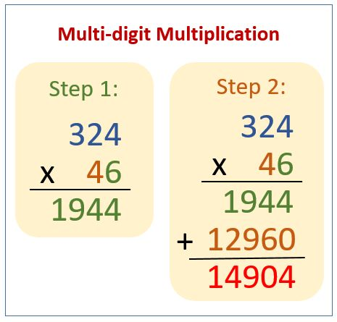Key Instant Recall Facts (KIRFs) are designed to support the development of the mental skills that underpin much of the maths work in school. Instant recall facts help enormously with mental agility within maths lessons.



1. In step 1 start by multiplying 6x4 = 24
2. Then 6x2 = 12
3. Then 6x3 = 18
4. Move onto step 2
5. Add a 0 to the end of your second number.
6. Then multiply 4x4 =16
7. Then 4x2 = 8
8. Then 4x3 = 12
9. Step 3- add both your answers together to get your final answer.

Your child’s KIRF this term is: Multiplying by a 2-digit numbers.

In addition, you can help by practising the following:

|  |  |
| --- | --- |
| Short division | 186 ÷ 6 = 31 |
| Multiplying fractions by an integer |  |
| Fractions of an amount |  |
| Decimals | **1 3 . 2 5** |