**Nursery Talk Tasks 11.09.23**

**This week we want your child to know:**

**Key Vocabulary:**

**Body Parts**

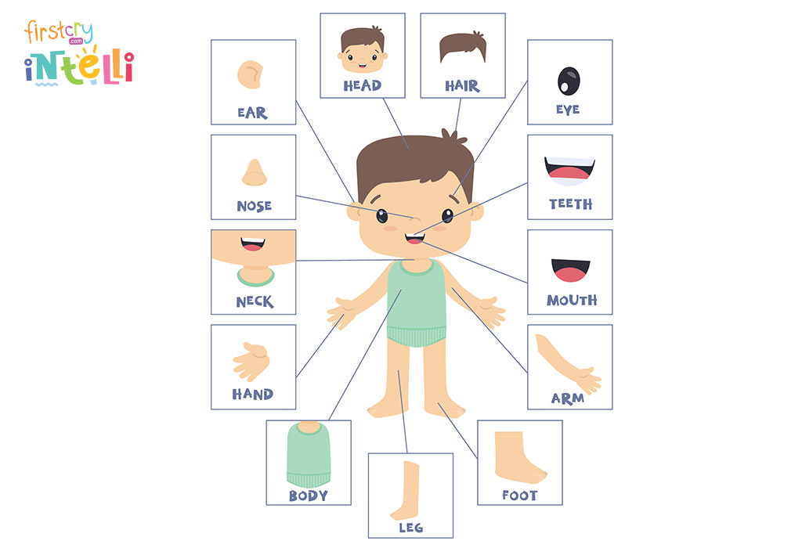

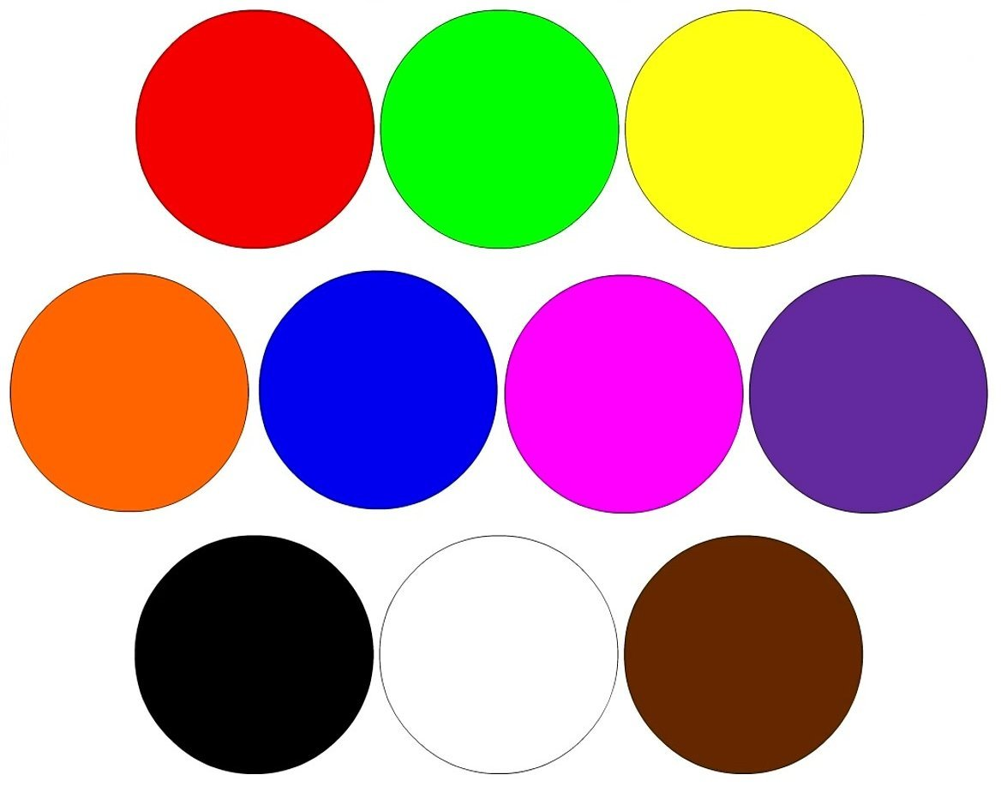 **Common Colours**

The names of their teachers at nursery

**In Nursery this week:**

|  |  |
| --- | --- |
| Song of the week | The Nursery ‘Hello’ Song  The Nursery ‘Goodbye’ Song |
| Phonics | We will be making sounds with parts of our bodies (body percussion) e.g. clapping, stamping, tapping, patting, clicking |
| Maths | This week we are exploring and naming colours. We will be looking at the Colour Monster Book |
| Please Note | Please email a photograph of who lives in your house for our families display to  nursery-teachers@heymann.notts.sch.uk |

* [Show your child the photographs of the nursery staff, can they name them?](https://www.heymann.notts.sch.uk/page/?title=Nursery+Staff&pid=70&action=saved)
* Talk to your child about who or what they have played

with at nursery today. Remember they may find this very difficult and not tell you very much at the moment, this is what we would expect.

Things to try at home: