Things to know:

Key Vocabulary:

Equal means the same as
Objects are made of different materials and feel different – some feel hard and some feel soft
We can make up a new story by changing the characters
A digraph is 2 letters making one sound. New digraphs this week – qu and ch,

Comparing Quantities

more than fewer than
equal 

Hard Soft Sort

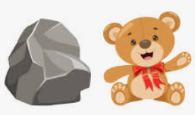

Things we are Learning
English and phonics Focus | Talk for Write: Baby Mouse -changing the characters to make a new story  -Making up our own stories.  Phonics Phase 2: sound we have learnt so far:  S a t p i n m d g o c k ck e u r h b l f ff ll ss j v w x y z qu ch  name writing/writing a list of cvc words
Maths focus | Comparing Quantities – This week children will be encouraged to compare numbers in 2 sets by matching them 1-1. Seeing that objects in some sets can be matched without any being left over will draw the children’s attention to instances when the quantities of objects are equal.
Other | Drawing, cutting, pencil skills, moulding and shaping playdough to make an animal, sorting materials turn taking, sharing and making a list.

