**Things to know:**

**Key Vocabulary:**

**Names of animals that live on a farm.**

**How to draw a line and label a picture.**

**Numerals 1-5.**

**Things we are Learning**

|  |  |
| --- | --- |
| **English and phonics Focus** | Farms- Which animals live on a farm? How to label a picture.  Phonics-Phase 3. This week we are learning the phonemes ‘oo’, ‘oo’, ‘ar’, and 'or’. |
| **Maths focus** | This week we will be learning to order numbers and count group of objects. We will build towers of cubes 1-5 and order them noticing each tower has one more. |
| **Other** | Making animal homes inside and outside.  Making animal food in the mud kitchen.  Drawing simple representations of animals  Singing counting songs. |
|  |  |

**1 more, order, numeral**

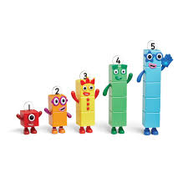

**1 2 3 4 5**

**Sty, label, pig, sheep, horse, cow, hen**



