**Things to talk about at home:**

**Key Vocabulary:**

Talk to your child about stay and play this week

Can you catch a large ball?

What are your favourite foods to eat? Do you know what foods are healthy?

What is your favourite story?

**Setting**

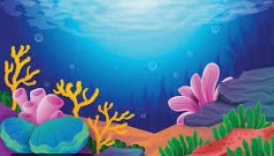

**Character**

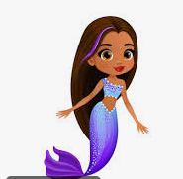

**Double**

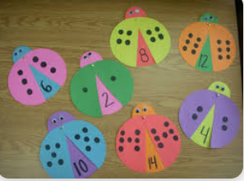

**Things we are Learning**

|  |  |
| --- | --- |
| **English and phonics Focus** | Letter formation  Telling stories and thinking about characters and settings  Phonics Phase three- review and assess |
| **Maths focus** | Doubling  Careful counting |
| **Other** | Red nose day on Friday the 21st of March  Children can wear red!!  Attaching: Continue to use the appropriate method to attach – glue stick, PVA, tape  Ball skills |
|  |  |