**Things to talk about at home:**

**Key Vocabulary:**

Indian flag

Weather

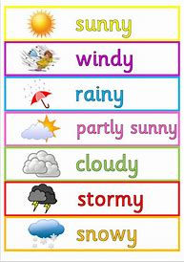

Circle



Do you know the name of the country you live in?

What languages do you speak at home?

Write your name and practise zipping up your coat

Things we are Learning

|  |  |
| --- | --- |
| **English and phonics Focus** | Comparing England and India : the weather, the wild animals  Letter formation  Phonics Phase three and four |
| **Maths focus** | Sorting numbers odds and evens |
| **Other** | Attaching: Continue to use the appropriate method to attach – glue stick, PVA, tape  Gymnastics |
|  |  |